**LAB FILE**

**Introduction to C programming**

`

**Batch-2023-26**

**Section- D BCA(AI&DS)**

Submitted by Submitted to

Vaidansh Thapliyal Mr.Rishi Kuamr

23091264 Ass.Prof.CS/IT

GEU

**Table of Contents**

|  |  |  |  |  |
| --- | --- | --- | --- | --- |
| S.No | Topic | Page | Student’s signature | Teacher’s signature |
| 1 | **WAP for hello world or this is my first C Program.** |  |  |  |
| 2 | **WAP to add two numbers.** |  |  |  |
| 3 | WAP to find area of circle. |  |  |  |
| 4 | WAP to divide two numbers |  |  |  |
| 5 | WAP to print ASCII value. |  |  |  |
| 6 | WAP to multiply floating point numbers |  |  |  |
| 7 | WAP to SWAP two vairables number by using third variable. |  |  |  |
| 8 | WAP to SWAP two vairables number without using third variable |  |  |  |
| 9 | WAP to SWAP three vairable numbers without using third variables. |  |  |  |
| 10 | Wap to find the area of rectangle |  |  |  |
| 11 | WAP to find area of square |  |  |  |
| 12 | wap to find area of right angle triangle, isosceles triangle, any triangle with 3 sides |  |  |  |
| 13 | wap to find Area and Volume of Cube. |  |  |  |
| 14 | wap to find area and volume of cuboid. |  |  |  |
| 15 | WAP to find the largest number using the Logical AND operator |  |  |  |
| 16 | WAP to validate the username and password entered by the user is correct or not using the predefined username and password |  |  |  |
| 17 | WAP to input the positive number from the user to perform the Left shift operator |  |  |  |
| 18 | WAP to input the positive number from the user to perform the Right shift operator |  |  |  |
| 19 | WAP to perform the pre increment and pre decrement operator on two integers and print both original value and updated value |  |  |  |
| 20 | WAP to perform the post increment and post decrement operator on two integers and print both original value and updated value. |  |  |  |
| 21 | WAP for an integer number and to check whether it is divisible by 9 or 7 using OR logical operator |  |  |  |
| 22 | WAP to identify gender in single character and print full gender (Ex: if input is 'M' or 'm' – it should print "Male"). |  |  |  |
|  |  |  |  |  |

Programm-1

**WAP to Print HELLO WORLD**

**Input**

#include <stdio.h>

int main() {

printf("Vaidansh\n");

printf("Hello, World!\n");

return 0;

}

**OUTPUT**

**Programm-2**

**WAP to add two numbers**

**INPUT**

#include <stdio.h>

int main() {

// Declare variables

double num1, num2, sum;

// Get input from the user

printf("Enter the first number: ");

scanf("%lf", &num1);

printf("Enter the second number: ");

scanf("%lf", &num2);

// Calculate the sum

sum = num1 + num2;

// Display the result along with "Vaidansh"

printf("The sum of %.2lf and %.2lf is %.2lf\n", num1, num2, sum);

printf("Hello Vaidansh!\n");

return 0;

}

OUTPUT

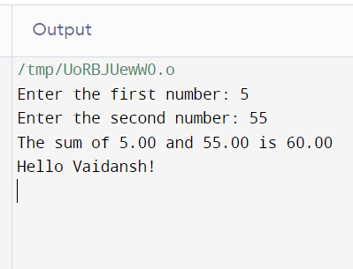

**Programme-3**

**WAP to find area of circle**

**Input**

#include <stdio.h>

#include <math.h>

int main() {

// Print the name "Vaidansh"

printf("Vaidansh\n");

// Declare variables for circle calculation

double radius, area;

// Get the radius of the circle from the user

printf("Enter the radius of the circle: ");

scanf("%lf", &radius);

// Calculate the area of the circle

area = M_PI * pow(radius, 2);

// Display the area of the circle

printf("The area of the circle with radius %.2lf is %.2lf\n", radius, area);

return 0;

}

**Output**

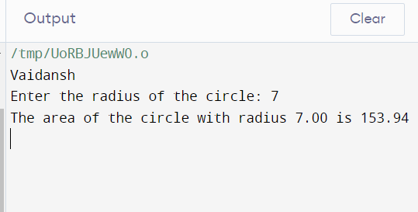

**Programme-4**

**WAP to divide two numbers**

**Input**

#include <stdio.h>

int main() {

// Print your name

printf("Vaidansh\n");

// Define two numbers

float num1, num2;

// Prompt the user for input

printf("Enter the first number: ");

scanf("%f", &num1);

printf("Enter the second number: ");

scanf("%f", &num2);

// Check if the second number is not zero to avoid division by zero

if (num2 != 0) {

// Divide the numbers and print the result

float result = num1 / num2;

printf("Result of division: %.2f\n", result);

} else {

printf("Error: Division by zero is not allowed.\n");

}

return 0;

}

**Output**

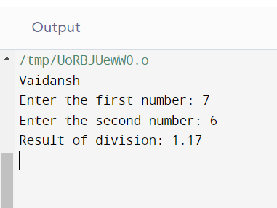

**Programme-5**

**WAP to Print ASCII Value**

**Input**

#include <stdio.h>

int main() {

char name[] = "Vaidansh";

// Print your name

printf("Name: %s\n", name);

// Print the ASCII values of the characters in the name

printf("ASCII Values:\n");

for (int i = 0; name[i] != '\0'; i++) {

printf("%c: %d\n", name[i], name[i]);

}

return 0;

}

**OUTPUT**

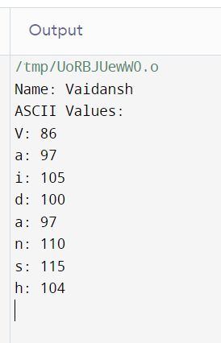

**Programme-6**

**WAP to Multifly floating Point numbers**

**Input**

#include <stdio.h>

int main() {

// Print your name

printf("Vaidansh\n");

// Define two floating-point numbers

float num1, num2;

// Prompt the user for input

printf("Enter the first floating-point number: ");

scanf("%f", &num1);

printf("Enter the second floating-point number: ");

scanf("%f", &num2);

// Multiply the numbers and print the result

float result = num1 * num2;

printf("Result of multiplication: %.2f\n", result);

return 0;

}

**Output**

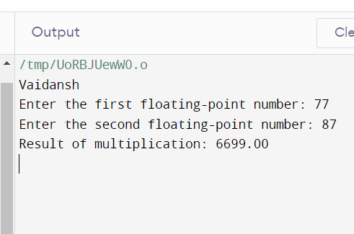

**Programme-7**

**WAP to SWAP Two Variable Numbers by Using Third Variable**

**Intput**

#include <stdio.h>

int main() {

// Print your name

printf("Vaidansh\n");

// Define two variables

int num1, num2;

// Prompt the user for input

printf("Enter the first number: ");

scanf("%d", &num1);

printf("Enter the second number: ");

scanf("%d", &num2);

// Swap the values using a third variable

int temp;

temp = num1;

num1 = num2;

num2 = temp;

// Print the swapped values

printf("After swapping:\n");

printf("First number: %d\n", num1);

printf("Second number: %d\n", num2);

return 0;

}

**Output**

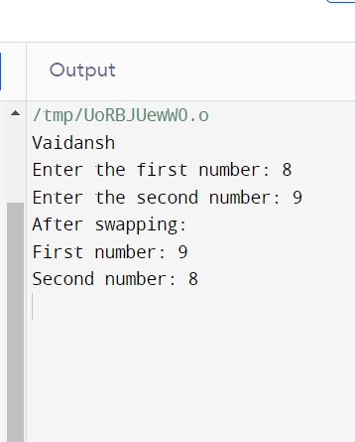

**Programm-8**

**WAP to Swap to Variable Without Using Third Variable**

**Input**

#include <stdio.h>

int main() {

// Print your name

printf("Vaidansh\n");

// Define two variables

int num1, num2;

// Prompt the user for input

printf("Enter the first number: ");

scanf("%d", &num1);

printf("Enter the second number: ");

scanf("%d", &num2);

// Swap the values without using a third variable

num1 = num1 ^ num2;

num2 = num1 ^ num2;

num1 = num1 ^ num2;

// Print the swapped values

printf("After swapping:\n");

printf("First number: %d\n", num1);

printf("Second number: %d\n", num2);

return 0;

}

**Output**

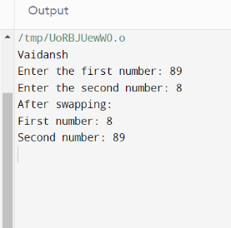

**Programme-9**

**Wap to Swap Three Variable Numbers Without Using Third Varible**

**Input**

#include <stdio.h>

int main() {

// Print your name

printf("Vaidansh\n");

// Define three variables

int num1, num2, num3;

// Prompt the user for input

printf("Enter the first number: ");

scanf("%d", &num1);

printf("Enter the second number: ");

scanf("%d", &num2);

printf("Enter the third number: ");

scanf("%d", &num3);

// Swap the values without using a third variable

num1 = num1 + num2 + num3;

num2 = num1 - (num2 + num3);

num3 = num1 - (num2 + num3);

num1 = num1 - (num2 + num3);

// Print the swapped values

printf("After swapping:\n");

printf("First number: %d\n", num1);

printf("Second number: %d\n", num2);

printf("Third number: %d\n", num3);

return 0;

}

**Output**

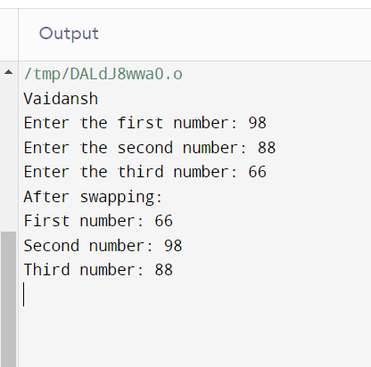

**Programme-10**

**WAP to Find the Area of Rectangle**

**Input**

#include <stdio.h>

int main() {

// Print your name

printf("Vaidansh\n");

// Define variables for length and width of the rectangle

float length, width;

// Prompt the user for input

printf("Enter the length of the rectangle: ");

scanf("%f", &length);

printf("Enter the width of the rectangle: ");

scanf("%f", &width);

// Calculate the area of the rectangle

float area = length * width;

// Print the result

printf("The area of the rectangle is: %.2f square units\n", area);

return 0;

}

**Output**

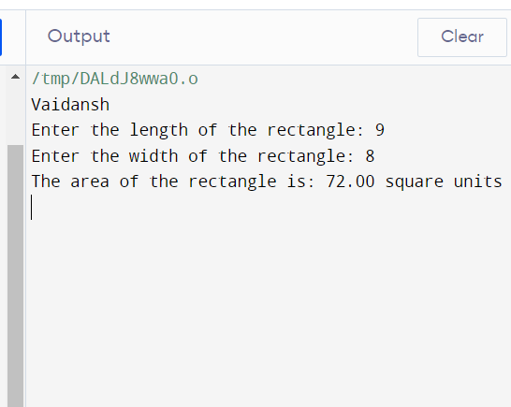

**Programme-11**

**WAP to Find Area of Square**

**Input**

#include <stdio.h>

int main() {

// Print your name

printf("Vaidansh\n");

// Define a variable for the side length of the square

float sideLength;

// Prompt the user for input

printf("Enter the side length of the square: ");

scanf("%f", &sideLength);

// Calculate the area of the square

float area = sideLength * sideLength;

// Print the result

printf("The area of the square is: %.2f square units\n", area);

return 0;

}

**Output**

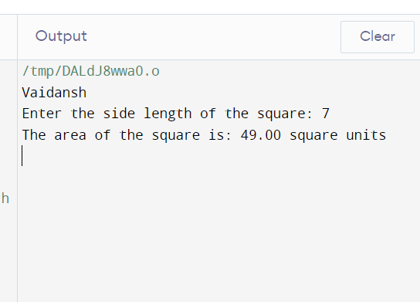

**Programme-12**

**WAP to find area of right angle triangle, isosceles triangle triangle, any triangle with three sides**

**Input**

#include <stdio.h>

#include <math.h>

int main() {

// Print your name

printf("Vaidansh\n");

// Choice for the type of triangle (1 = right-angled, 2 = isosceles, 3 = any)

int choice;

printf("Choose the type of triangle (1 = Right-Angled, 2 = Isosceles, 3 = Any): ");

scanf("%d", &choice);

switch (choice) {

case 1: {

// Right-Angled Triangle

float base, height;

printf("Enter the base of the right-angled triangle: ");

scanf("%f", &base);

printf("Enter the height of the right-angled triangle: ");

scanf("%f", &height);

// Calculate the area

float area = 0.5 * base * height;

printf("The area of the right-angled triangle is: %.2f square units\n", area);

break;

}

case 2: {

// Isosceles Triangle

float base, sides;

printf("Enter the length of the base of the isosceles triangle: ");

scanf("%f", &base);

printf("Enter the length of the equal sides of the isosceles triangle: ");

scanf("%f", &sides);

// Calculate the area

float area = 0.5 * base * sqrt(sides * sides - (base * base) / 4);

printf("The area of the isosceles triangle is: %.2f square units\n", area);

break;

}

case 3: {

// Any Triangle (using Heron's formula)

float a, b, c;

printf("Enter the lengths of the three sides of the triangle: ");

scanf("%f %f %f", &a, &b, &c);

// Calculate the semi-perimeter

float s = (a + b + c) / 2;

// Calculate the area using Heron's formula

float area = sqrt(s * (s - a) * (s - b) * (s - c));

printf("The area of the triangle is: %.2f square units\n", area);

break;

}

default:

printf("Invalid choice. Please choose 1, 2, or 3.\n");

}

return 0;

}

**Output**

3

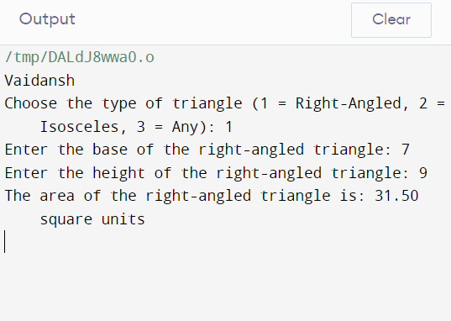

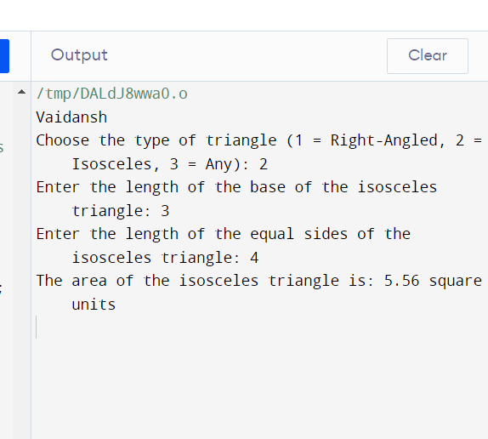

**Programme-13**

**WAP to find area and volume of cube**

**Input**

#include <stdio.h>

int main() {

// Print your name

printf("Vaidansh\n");

// Calculate the area and volume of a cube

double side_length = 5.0; // Replace with your desired side length

double area = 6 * side_length * side_length;

double volume = side_length * side_length * side_length;

// Print the calculated values

printf("Area of the cube: %.2lf square units\n", area);

printf("Volume of the cube: %.2lf cubic units\n", volume);

return 0;

}

**Output**

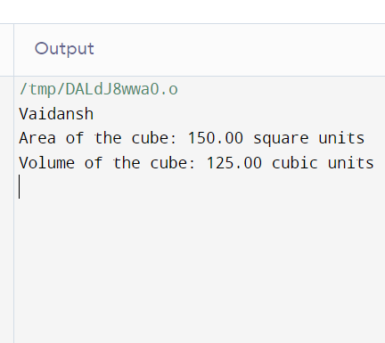

**Programme-14**

**WAP to find area and volume of cuboid**

**Input**

#include <stdio.h>

int main() {

// Print your name

printf("Vaidansh\n");

// Define the dimensions of the cuboid

double length = 5.0; // Replace with the length of the cuboid

double width = 3.0; // Replace with the width of the cuboid

double height = 4.0; // Replace with the height of the cuboid

// Calculate the area and volume of the cuboid

double surface_area = 2 * (length * width + length * height + width * height);

double volume = length * width * height;

// Print the calculated values

printf("Surface Area of the cuboid: %.2lf square units\n", surface_area);

printf("Volume of the cuboid: %.2lf cubic units\n", volume);

return 0;

}

**Output**

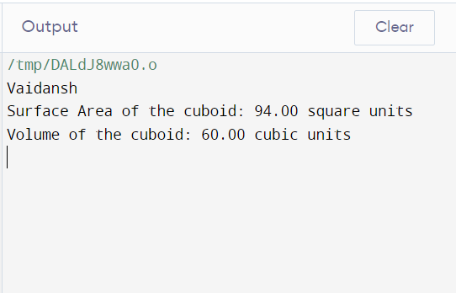

**Programme-15**

**WAP to Find the largest number using the Logical AND Operator**

**Input**

#include <stdio.h>

int main() {

// Print your name

printf("Vaidansh\n");

// Declare and initialize variables for numbers

int num1, num2, num3;

// Prompt the user to enter three numbers

printf("Enter three numbers: ");

scanf("%d %d %d", &num1, &num2, &num3);

// Initialize a variable to store the largest number

int largest;

// Use logical AND operator to find the largest number

if (num1 >= num2 && num1 >= num3) {

largest = num1;

} else if (num2 >= num1 && num2 >= num3) {

largest = num2;

} else {

largest = num3;

}

// Print the largest number

printf("The largest number is: %d\n", largest);

return 0;

}

**Output**

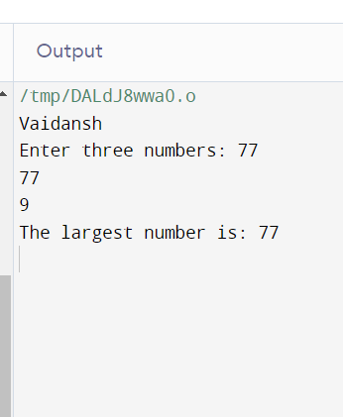

**Programme-16**

**WAP to validate the username and password entered by the user is correct or not using the predefined username and password.**

**Input**

#include <stdio.h>

#include <string.h> // For strcmp function

int main() {

// Print your name

printf("Vaidansh\n");

// Predefined username and password

char correctUsername[] = "myusername";

char correctPassword[] = "mypassword";

// Variables to store user input

char enteredUsername[50];

char enteredPassword[50];

// Prompt the user to enter username and password

printf("Enter username: ");

scanf("%s", enteredUsername);

printf("Enter password: ");

scanf("%s", enteredPassword);

// Compare entered username and password with predefined values

if (strcmp(enteredUsername, correctUsername) == 0 && strcmp(enteredPassword, correctPassword) == 0) {

printf("Access granted. Welcome!\n");

} else {

printf("Access denied. Invalid username or password.\n");

}

return 0;

}

**Output**

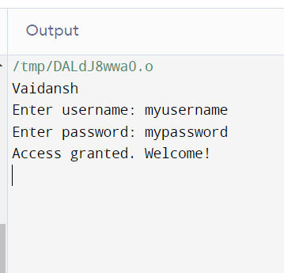

**Programme-17**

**WAP to input the positive number from the user to perform the Left shift operator**

**INPUT**

#include <stdio.h>

int main() {

// Print your name

printf("Vaidansh\n");

// Declare variables

unsigned int num, shift;

// Prompt the user to enter a positive number

printf("Enter a positive number: ");

scanf("%u", &num);

// Check if the entered number is positive

if (num < 0) {

printf("Invalid input. Please enter a positive number.\n");

} else {

// Prompt the user to enter the number of bits to shift

printf("Enter the number of bits to left shift: ");

scanf("%u", &shift);

// Perform left shift operation

unsigned int result = num << shift;

// Display the result

printf("Result of left shift operation: %u\n", result);

}

return 0;

}

**Output**

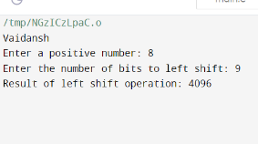

**Programme-18**

**WAP to input the positive number from the user to perform the Right shift operator.**

**Input**

#include <stdio.h>

int main() {

// Print your name

printf("Vaidansh\n");

// Declare variables

unsigned int num, shift;

// Prompt the user to enter a positive number

printf("Enter a positive number: ");

scanf("%u", &num);

// Check if the entered number is positive

if (num < 0) {

printf("Invalid input. Please enter a positive number.\n");

} else {

// Prompt the user to enter the number of bits to right shift

printf("Enter the number of bits to right shift: ");

scanf("%u", &shift);

// Perform right shift operation

unsigned int result = num >> shift;

// Display the result

printf("Result of right shift operation: %u\n", result);

}

return 0;

}

**Output**

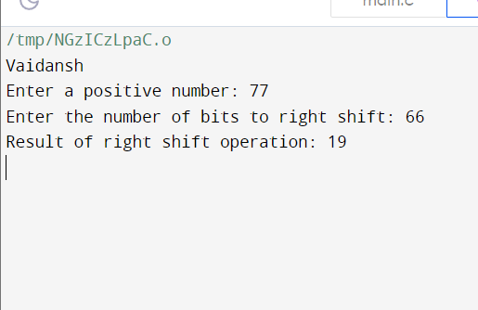

**Programme-19**

**WAP to perform the pre increment and pre decrement operator on two integers and print both original value and updated value.**

**Input**

#include <stdio.h>

int main() {

// Print your name

printf("Vaidansh\n");

// Declare and initialize two integers

int num1 = 5;

int num2 = 10;

// Perform pre-increment and pre-decrement operations

printf("Original value of num1: %d\n", num1);

printf("Original value of num2: %d\n", num2);

++num1; // Pre-increment num1

--num2; // Pre-decrement num2

// Print the updated values

printf("Updated value of num1 (after pre-increment): %d\n", num1);

printf("Updated value of num2 (after pre-decrement): %d\n", num2);

return 0;

}

**Output**

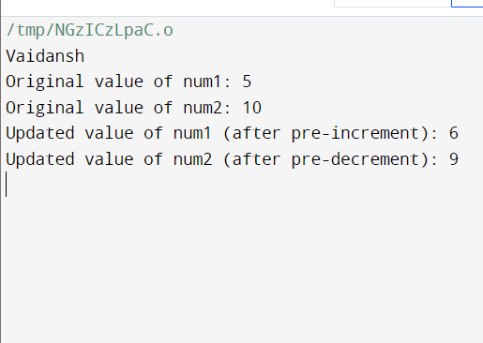

**Programme-20**

**WAP to perform the post increment and post decrement operator on two integers and print both original value and updated value.**

**Input**

#include <stdio.h>

int main() {

// Print your name

printf("Vaidansh\n");

// Declare and initialize two integers

int num1 = 5;

int num2 = 10;

// Perform post-increment and post-decrement operations

printf("Original value of num1: %d\n", num1);

printf("Original value of num2: %d\n", num2);

num1++; // Post-increment num1

num2--; // Post-decrement num2

// Print the updated values

printf("Updated value of num1 (after post-increment): %d\n", num1);

printf("Updated value of num2 (after post-decrement): %d\n", num2);

return 0;

}

**Output**

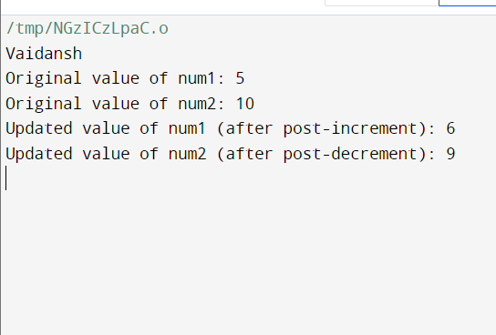

**Programme-21**

**WAP for an integer number and to check whether it is divisible by 9 or 7 using OR logical operator**

**Input**

#include <stdio.h>

int main() {

// Print your name

printf("Vaidansh\n");

// Declare a variable for the integer number

int number;

// Prompt the user to enter an integer

printf("Enter an integer: ");

scanf("%d", &number);

// Check if the number is divisible by 9 or 7

if (number % 9 == 0 || number % 7 == 0) {

printf("%d is divisible by 9 or 7.\n", number);

} else {

printf("%d is not divisible by 9 or 7.\n", number);

}

return 0;

}

**Output**

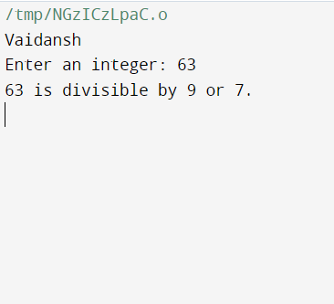

**Programme-22**

**WAP to identify gender in single character and print full gender (Ex: if input is 'M' or 'm' – it should print "Male")**

**Input**

#include <stdio.h>

int main() {

// Print your name

printf("Vaidansh\n");

// Declare a variable for the gender input

char gender;

// Prompt the user to enter a single character gender input

printf("Enter gender ('M' for Male or 'F' for Female): ");

scanf(" %c", &gender); // Note the space before %c to consume any newline characters

// Check the input character to determine the gender and print the full gender

switch (gender) {

case 'M':

case 'm':

printf("Male\n");

break;

case 'F':

case 'f':

printf("Female\n");

break;

default:

printf("Invalid input for gender.\n");

break;

}

return 0;

}

**Output**

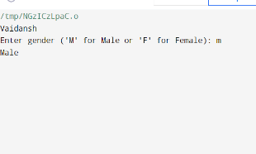

Programme - 23

Write a C program to print all natural numbers in reverse (from n to 1).

Input

#include <stdio.h>

int main() {

printf("vaidansh\n");

int n;

printf("Enter a positive integer: ");

scanf("%d", &n);

if (n <= 0) {

printf("Please enter a positive integer.\n");

return 1; // Exit with an error code

}

printf("Natural numbers from %d to 1 in reverse order:\n", n);

while (n >= 1) {

printf("%d ", n);

n--;

}

printf("\n");

return 0; // Exit successfully

}

Output

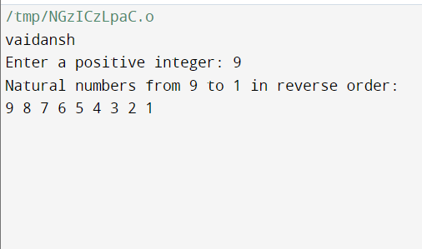

**Programme-24**

Write a C program to print all alphabets from a to z

INPUT

#include <stdio.h>

int main() {

printf("vaidansh thapliyal\n");

printf("Alphabets from a to z:\n");

char alphabet = 'a';

while (alphabet <= 'z') {

printf("%c ", alphabet);

alphabet++;

}

printf("\n");

return 0; // Exit successfully

}

Output

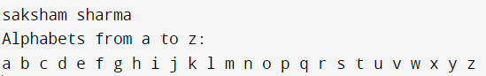

**Programme-25**

Write a C Write a C program to print all natural numbers from 1 to n.

Input

#include <stdio.h>

int main() {

printf("vaidansh thapliyal\n");

int n;

printf("Enter a positive integer: ");

scanf("%d", &n);

if (n <= 0) {

printf("Please enter a positive integer.\n");

return 1; // Exit with an error code

}

printf("Natural numbers from 1 to %d:\n", n);

for (int i = 1; i <= n; i++) {

printf("%d ", i);

}

printf("\n");

return 0; // Exit successfully

}

Output

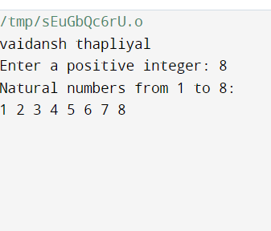

**Programme -26**

program to print all even numbers between 1 to 100.

Input

#include <stdio.h>

int main() {

printf("vaidansh\n");

// Printing even numbers between 1 to 100

printf("Even numbers between 1 to 100: ");

for (int i = 1; i <= 100; ++i) {

if (i % 2 == 0) {

printf("%d ", i);

}

}

printf("\n");

return 0;

}

Output

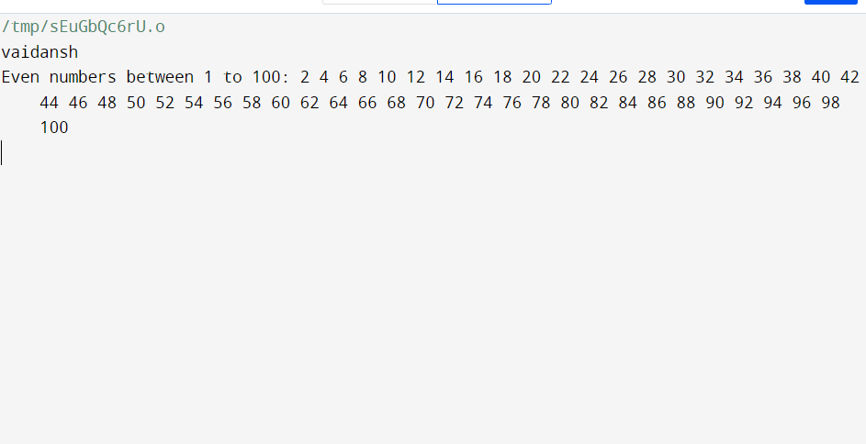

**Programme -27**

Write a C program to print all odd number between 1 to 100

Input

#include <stdio.h>

int main() {

printf("vaidansh\n");

// Printing odd numbers between 1 to 100

printf("Odd numbers between 1 to 100: ");

for (int i = 1; i <= 100; ++i) {

if (i % 2 != 0) {

printf("%d ", i);

}

}

printf("\n");

return 0;

}

Output

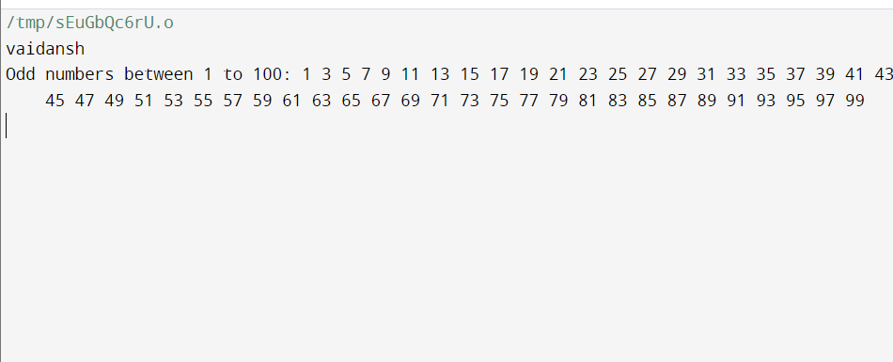

**Programme-28**

Write a C program to find sum of all natural numbers between 1 to n.

**Input**

#include <stdio.h>

int main() {

int n, i, sum = 0;

// Print "vaidansh"

printf("vaidansh\n");

// Read input from the user

printf("Enter a positive integer n: ");

scanf("%d", &n);

// Calculate the sum of natural numbers from 1 to n

for (i = 1; i <= n; ++i) {

sum += i;

}

// Print the sum

printf("Sum of natural numbers from 1 to %d is: %d\n", n, sum);

return 0;

}

**Output**

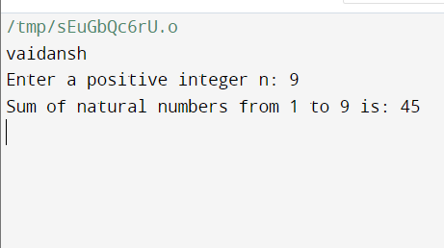

**Programme-29**

Write a C program to find sum of all even numbers between 1 to n.

Input

#include <stdio.h>

int main() {

int n, i, sum = 0;

// Print "vaidansh"

printf("vaidansh\n");

// Read input from the user

printf("Enter a positive integer n: ");

scanf("%d", &n);

// Calculate the sum of even numbers from 2 to n

for (i = 2; i <= n; i += 2) {

sum += i;

}

// Print the sum

printf("Sum of even numbers from 2 to %d is: %d\n", n, sum);

return 0;

}

Output

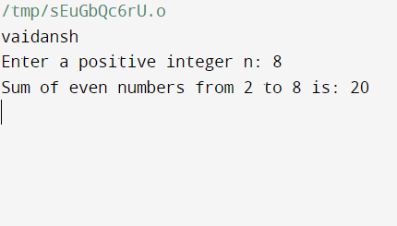

Programme-30

Write a C program to find sum of all odd numbers between 1 to n.

Input

#include <stdio.h>

int main() {

int n, i, sum = 0;

// Print "vaidansh"

printf("vaidansh\n");

// Read input from the user

printf("Enter a positive integer n: ");

scanf("%d", &n);

// Calculate the sum of odd numbers from 1 to n

for (i = 1; i <= n; i += 2) {

sum += i;

}

// Print the sum

printf("Sum of odd numbers from 1 to %d is: %d\n", n, sum);

return 0;

}

Output

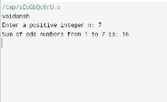

Programme-31

Write a C program to print multiplication table of any number

INPUT

#include <stdio.h>

int main() {

// Print the name

printf("vaidansh thapliyal\n");

// Read input from the user

int number, i;

printf("Enter a number: ");

scanf("%d", &number);

// Print the multiplication table

printf("Multiplication table for %d:\n", number);

for (i = 1; i <= 10; ++i) {

printf("%d x %d = %d\n", number, i, number * i);

}

return 0;

}

OUTPUT

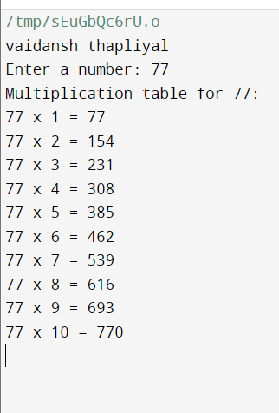

Programme-32

Write a C program to count number of digits in a number

**INPUT**

#include <stdio.h>

int main() {

// Print the name

printf("vaidansh\n");

// Read input from the user

int number, count = 0;

printf("Enter a number: ");

scanf("%d", &number);

// Count the number of digits

int temp = number;

while (temp != 0) {

temp /= 10;

++count;

}

// Print the count of digits

printf("Number of digits in %d is: %d\n", number, count);

return 0;

}

**OUTPUT**

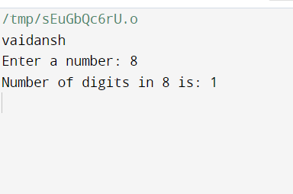

Programme-33

Write a C program to find first and last digit of a number.

INPUT

#include <stdio.h>

int main() {

// Print the name

printf("vaidansh\n");

// Read input from the user

int number, firstDigit, lastDigit;

printf("Enter a number: ");

scanf("%d", &number);

// Find the first digit

firstDigit = number;

while (firstDigit >= 10) {

firstDigit /= 10;

}

// Find the last digit

lastDigit = number % 10;

// Print the first and last digits

printf("First digit: %d\n", firstDigit);

printf("Last digit: %d\n", lastDigit);

return 0;

}  
 OUTPUT

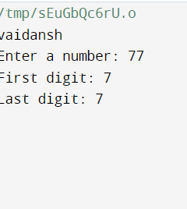

Programme-34

Write a C program to find sum of first and last digit of a number

INPUT

#include <stdio.h>

int main() {

// Print the name

printf("vaidansh\n");

// Read input from the user

int number, firstDigit, lastDigit, sum;

printf("Enter a number: ");

scanf("%d", &number);

// Find the first digit

firstDigit = number;

while (firstDigit >= 10) {

firstDigit /= 10;

}

// Find the last digit

lastDigit = number % 10;

// Calculate the sum of first and last digits

sum = firstDigit + lastDigit;

// Print the sum of first and last digits

printf("Sum of first and last digit: %d\n", sum);

return 0;

}

OUTPUT

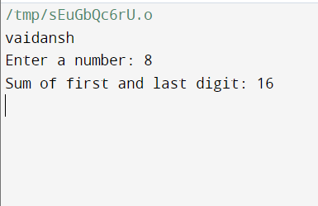

Programme-35

Write a C program to swap first and last digits of a number.

INPUT

#include <stdio.h>

int main() {

// Print the name

printf("vaidansh\n");

// Read input from the user

int number, originalNumber, numDigits = 0, firstDigit, lastDigit, swappedNumber = 0, multiplier = 1;

printf("Enter a number: ");

scanf("%d", &number);

originalNumber = number;

// Find the number of digits in the number

while (number != 0) {

number /= 10;

numDigits++;

}

number = originalNumber;

// Find the first and last digits

lastDigit = number % 10;

while (number >= 10) {

number /= 10;

multiplier *= 10;

}

firstDigit = number;

// Swap the first and last digits

swappedNumber = lastDigit * multiplier;

swappedNumber += originalNumber % multiplier;

swappedNumber -= lastDigit;

swappedNumber += firstDigit;

// Print the swapped number

printf("Number after swapping first and last digits: %d\n", swappedNumber);

return 0;

}

OUTPUT

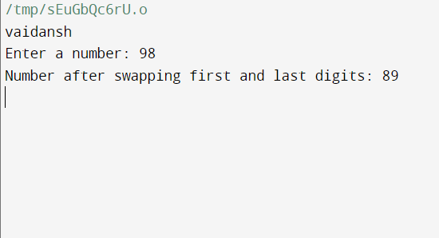

Programme-36

Write a C program to calculate sum of digits of a number

INPUT

#include <stdio.h>

int main() {

// Print the name

printf("vaidansh\n");

// Read input from the user

int number, originalNumber, sum = 0, digit;

printf("Enter a number: ");

scanf("%d", &number);

originalNumber = number;

// Calculate the sum of digits

while (number != 0) {

digit = number % 10;

sum += digit;

number /= 10;

}

// Print the sum of digits

printf("Sum of digits of %d is: %d\n", originalNumber, sum);

return 0;

}  
 OUTPUT

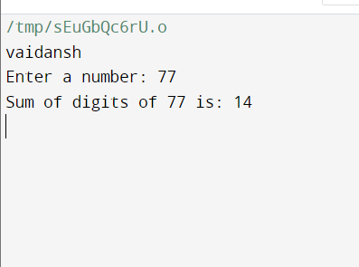

Programme-37

Write a C program to calculate product of digits of a number

INPUT

#include <stdio.h>

int main() {

// Print the name

printf("vaidansh\n");

// Read input from the user

int number, originalNumber, product = 1, digit;

printf("Enter a number: ");

scanf("%d", &number);

originalNumber = number;

// Calculate the product of digits

while (number != 0) {

digit = number % 10;

product *= digit;

number /= 10;

}

// Print the product of digits

printf("Product of digits of %d is: %d\n", originalNumber, product);

return 0;

}

OUTPUT

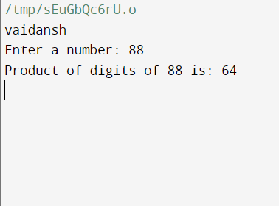

Programme-38

Write a C program to enter a number and print its reverse

INPUT

#include <stdio.h>

int main() {

// Print the name

printf("vaidansh\n");

// Read input from the user

int number, originalNumber, reversedNumber = 0, digit;

printf("Enter a number: ");

scanf("%d", &number);

originalNumber = number;

// Calculate the reverse of the number

while (number != 0) {

digit = number % 10;

reversedNumber = reversedNumber * 10 + digit;

number /= 10;

}

// Print the reverse of the number

printf("Reverse of %d is: %d\n", originalNumber, reversedNumber);

return 0;

}

OUTPUT

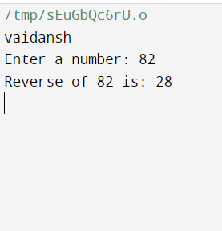

Programme-39

Write a C program to check whether a number is palindrome or not

**INPUT**

#include <stdio.h>

int main() {

// Print your name

printf("vaidansh\n");

// Ask user to enter a number

printf("Enter a number: ");

// Read the input number

int number, originalNumber, reversedNumber = 0, remainder;

scanf("%d", &number);

originalNumber = number;

// Reverse the number

while (number != 0) {

remainder = number % 10;

reversedNumber = reversedNumber * 10 + remainder;

number /= 10;

}

// Check if the number is a palindrome

if (originalNumber == reversedNumber) {

printf("%d is a palindrome number.\n", originalNumber);

} else {

printf("%d is not a palindrome number.\n", originalNumber);

}

return 0;

} **OUTPUT**

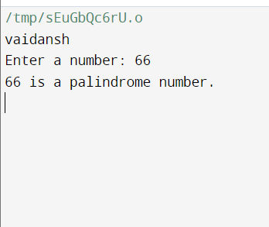

Programme-40

Write a C program to find frequency of each digit in a given integer

INPUT

#include <stdio.h>

#include <string.h>

void printVaidansh() {

printf("vaidansh\n");

}

void findDigitFrequency(int num) {

int digitCount[10] = {0};

while (num != 0) {

int digit = num % 10;

digitCount[digit]++;

num /= 10;

}

printf("Digit Frequency:\n");

for (int i = 0; i < 10; i++) {

if (digitCount[i] > 0) {

printf("Digit %d: %d times\n", i, digitCount[i]);

}

}

}

int main() {

printVaidansh();

int num;

printf("Enter an integer: ");

scanf("%d", &num);

findDigitFrequency(num);

return 0;

}  
 OUTPUT

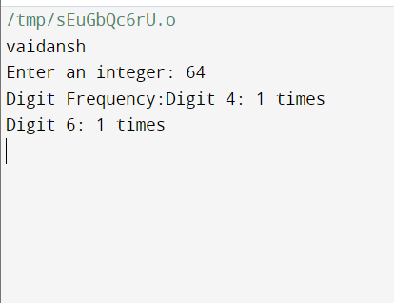

PROGRAMME-41

Write a C program to enter a number and print it in words

INPUT

#include <stdio.h>

void printVaidansh() {

printf("vaidansh\n");

}

void printNumberInWords(int num) {

char *units[] = {"Zero", "One", "Two", "Three", "Four", "Five", "Six", "Seven", "Eight", "Nine"};

char *tens[] = {"", "", "Twenty", "Thirty", "Forty", "Fifty", "Sixty", "Seventy", "Eighty", "Ninety"};

char *teens[] = {"Ten", "Eleven", "Twelve", "Thirteen", "Fourteen", "Fifteen", "Sixteen", "Seventeen", "Eighteen", "Nineteen"};

if (num >= 10 && num <= 19) {

printf("%s\n", teens[num - 10]);

} else {

int unitDigit = num % 10;

int tensDigit = (num / 10) % 10;

printf("%s", (tensDigit > 0) ? tens[tensDigit] : "");

if (tensDigit > 0 && unitDigit > 0) {

printf("-");

}

printf("%s\n", (unitDigit > 0) ? units[unitDigit] : "");

}

}

int main() {

printVaidansh();

int num;

printf("Enter a number (0 to 99): ");

scanf("%d", &num);

if (num < 0 || num > 99) {

printf("Number out of range. Please enter a number between 0 and 99.\n");

} else {

printf("Number in words: ");

printNumberInWords(num);

}

return 0;

}  
 OUTPUT

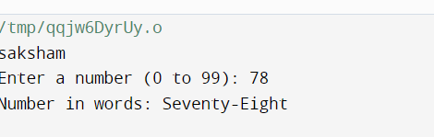

Programme-42

Write a C program to print all ASCII character with their values

INPUT

#include <stdio.h>

void printVaidansh() {

printf("vaidansh\n");

}

int main() {

printVaidansh();

printf("ASCII Characters with their Values:\n");

for (int i = 0; i <= 255; ++i) {

printf("ASCII value: %d, Character: %c\n", i, i);

}

return 0;

}  
 OUTPUT

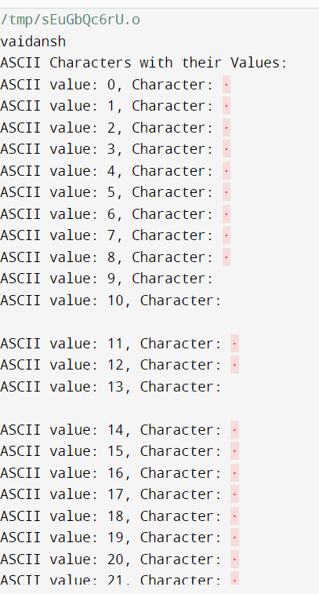

Programme-43

Write a C program to find power of a number using for loop

INPUT

#include <stdio.h>

void printVaidansh() {

printf("vaidansh\n");

}

int main() {

printVaidansh();

int base, exponent;

long long result = 1;

printf("Enter base: ");

scanf("%d", &base);

printf("Enter exponent: ");

scanf("%d", &exponent);

// Calculate power using a for loop

for (int i = 1; i <= exponent; ++i) {

result *= base;

}

printf("%d raised to the power %d is %lld\n", base, exponent, result);

return 0;

}

OUTPUT

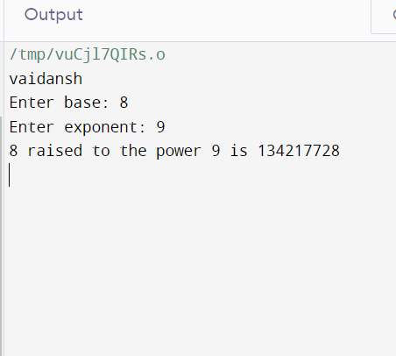

Programme-44

Write a C program to find all factors of a number

INPUT

#include <stdio.h>

void printVaidansh() {

printf("vaidansh\n");

}

void findFactors(int num) {

printf("Factors of %d are: ", num);

for (int i = 1; i <= num; ++i) {

if (num % i == 0) {

printf("%d ", i);

}

}

printf("\n");

}

int main() {

printVaidansh();

int num;

printf("Enter a number: ");

scanf("%d", &num);

findFactors(num);

return 0;

}  
 OUTPUT

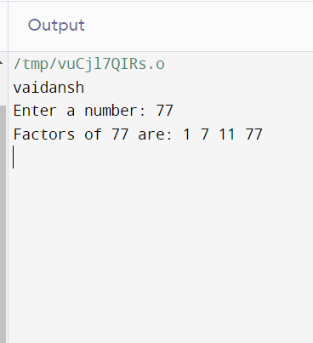

Programme-45

Write a C program to calculate factorial of a number

INPUT

#include <stdio.h>

void printJaiShreeRam() {

printf("JAI SHREE RAM\n");

}

unsigned long long factorial(int num) {

if (num == 0 || num == 1) {

return 1;

} else {

return num * factorial(num - 1);

}

}

int main() {

printJaiShreeRam();

int num;

printf("Enter a number: ");

scanf("%d", &num);

if (num < 0) {

printf("Factorial is not defined for negative numbers.\n");

} else {

unsigned long long fact = factorial(num);

printf("Factorial of %d is %llu\n", num, fact);

}

return 0;

}  
 OUTPUT

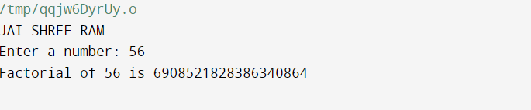

Programme-46

Write a C program to find HCF (GCD) of two numbers

INPUT

#include <stdio.h>

void printJaiShreeRam() {

printf("JAI SHREE RAM\n");

}

void printVaidansh() {

printf("vaidansh\n");

}

int findGCD(int num1, int num2) {

while (num2 != 0) {

int temp = num2;

num2 = num1 % num2;

num1 = temp;

}

return num1;

}

int main() {

printJaiShreeRam();

printVaidansh();

int num1, num2;

printf("Enter first number: ");

scanf("%d", &num1);

printf("Enter second number: ");

scanf("%d", &num2);

int gcd = findGCD(num1, num2);

printf("HCF (GCD) of %d and %d is %d\n", num1, num2, gcd);

return 0;

}

OUTPUT

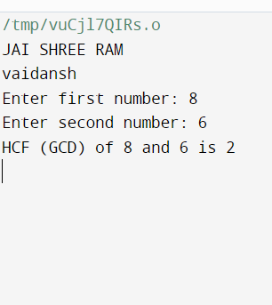

Programme-47

Write a C program to find LCM of two numbers

INPUT

#include <stdio.h>

void printVaidansh() {

printf("vaidansh\n");

}

int findGCD(int num1, int num2) {

while (num2 != 0) {

int temp = num2;

num2 = num1 % num2;

num1 = temp;

}

return num1;

}

long long findLCM(int num1, int num2) {

int gcd = findGCD(num1, num2);

long long lcm = (long long) num1 * num2 / gcd;

return lcm;

}

int main() {

printVaidansh();

int num1, num2;

printf("Enter first number: ");

scanf("%d", &num1);

printf("Enter second number: ");

scanf("%d", &num2);

long long lcm = findLCM(num1, num2);

printf("LCM of %d and %d is %lld\n", num1, num2, lcm);

return 0;

}

OUTPUT

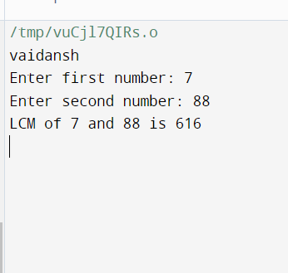

Programme-48

Write a C program to check whether a number is Prime number or not

INPUT

#include <stdio.h>

#include <stdbool.h>

void printVaidansh() {

printf("vaidansh\n");

}

bool isPrime(int num) {

if (num <= 1) {

return false;

}

for (int i = 2; i * i <= num; ++i) {

if (num % i == 0) {

return false;

}

}

return true;

}

int main() {

printVaidansh();

int num;

printf("Enter a number: ");

scanf("%d", &num);

if (isPrime(num)) {

printf("%d is a prime number.\n", num);

} else {

printf("%d is not a prime number.\n", num);

}

return 0;

}

OUTPUT

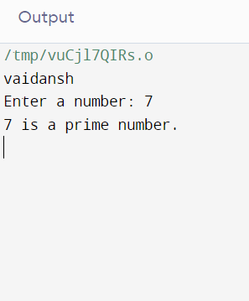

Programme-49

Write a C program to print all Prime numbers between 1 to n

INPUT

#include <stdio.h>

#include <stdbool.h>

void printVaidansh() {

printf("vaidansh\n");

}

bool isPrime(int num) {

if (num <= 1) {

return false;

}

for (int i = 2; i * i <= num; ++i) {

if (num % i == 0) {

return false;

}

}

return true;

}

int main() {

printVaidansh();

int n;

printf("Enter a number: ");

scanf("%d", &n);

printf("Prime numbers between 1 and %d are: ", n);

for (int i = 2; i <= n; ++i) {

if (isPrime(i)) {

printf("%d ", i);

}

}

printf("\n");

return 0;

}

OUTPUT

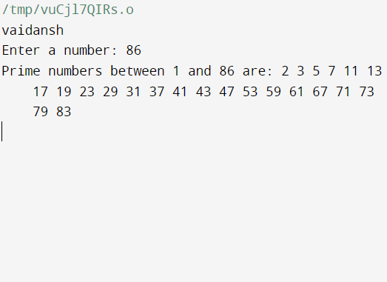

Programme-50

Write a C program to find sum of all prime numbers between 1 to n

INPUT

#include <stdio.h>

#include <stdbool.h>

void printVaidansh() {

printf("vaidansh\n");

}

bool isPrime(int num) {

if (num <= 1) {

return false;

}

for (int i = 2; i * i <= num; ++i) {

if (num % i == 0) {

return false;

}

}

return true;

}

int main() {

printVaidansh();

int n;

printf("Enter a number: ");

scanf("%d", &n);

int sum = 0;

for (int i = 2; i <= n; ++i) {

if (isPrime(i)) {

sum += i;

}

}

printf("Sum of all prime numbers between 1 and %d is: %d\n", n, sum);

return 0;

}

OUTPUT

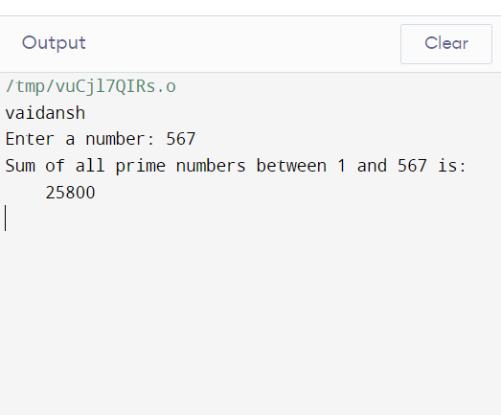

Programme-51

Write a C program to find all prime factors of a number

INPUT

#include <stdio.h>

void printVaidansh() {

printf("vaidansh\n");

}

void primeFactors(int num) {

printf("Prime factors of %d are: ", num);

int i;

for(i = 2; i <= num; i++) {

while(num % i == 0) {

printf("%d ", i);

num = num / i;

}

}

printf("\n");

}

int main() {

// Print "vaidansh"

printVaidansh();

// Get input from user

int number;

printf("Enter a number: ");

scanf("%d", &number);

// Find and print prime factors

primeFactors(number);

return 0;

}

OUTPUT

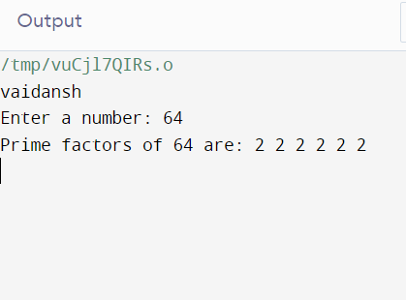

Programme-52

Write a C program to check whether a number is Armstrong number or not

INPUT

#include <stdio.h>

#include <math.h>

void printVaidansh() {

printf("vaidansh\n");

}

int isArmstrong(int num) {

int originalNum, remainder, result = 0, n = 0;

originalNum = num;

// Count number of digits

while (originalNum != 0) {

originalNum /= 10;

++n;

}

originalNum = num;

while (originalNum != 0) {

remainder = originalNum % 10;

result += pow(remainder, n);

originalNum /= 10;

}

// Check if the number is Armstrong

if (result == num)

return 1; // It is an Armstrong number

else

return 0; // It is not an Armstrong number

}

int main() {

// Print "vaidansh"

printVaidansh();

// Get input from user

int number;

printf("Enter a number: ");

scanf("%d", &number);

// Check if the number is Armstrong

if (isArmstrong(number)) {

printf("%d is an Armstrong number.\n", number);

} else {

printf("%d is not an Armstrong number.\n", number);

}

return 0;

}

OUTPUT

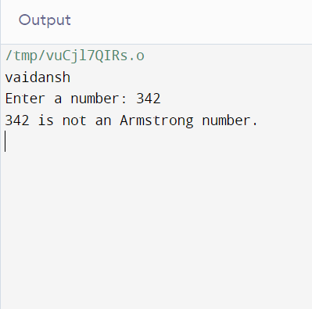

Programme-53

Write a C program to print all Armstrong numbers between 1 to n

INPUT

#include <stdio.h>

#include <math.h>

void printVaidansh() {

printf("vaidansh\n");

}

int isArmstrong(int num) {

int originalNum, remainder, result = 0, n = 0;

originalNum = num;

// Count number of digits

while (originalNum != 0) {

originalNum /= 10;

++n;

}

originalNum = num;

while (originalNum != 0) {

remainder = originalNum % 10;

result += pow(remainder, n);

originalNum /= 10;

}

// Check if the number is Armstrong

if (result == num)

return 1; // It is an Armstrong number

else

return 0; // It is not an Armstrong number

}

int main() {

// Print "vaidansh"

printVaidansh();

// Get input from user

int n;

printf("Enter a number: ");

scanf("%d", &n);

printf("Armstrong numbers between 1 to %d are: ", n);

// Check and print Armstrong numbers between 1 to n

for (int i = 1; i <= n; ++i) {

if (isArmstrong(i)) {

printf("%d ", i);

}

}

printf("\n");

return 0;

}

OUTPUT

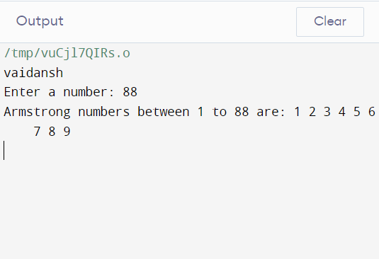

PROGRAMME-54

Write a C program to check whether a number is Perfect number or not

INPUT

#include <stdio.h>

void printVaidansh() {

printf("vaidansh\n");

}

int isPerfect(int num) {

int sum = 0;

for (int i = 1; i <= num / 2; ++i) {

if (num % i == 0) {

sum += i;

}

}

// Check if the number is Perfect

if (sum == num) {

return 1; // It is a Perfect number

} else {

return 0; // It is not a Perfect number

}

}

int main() {

// Print "vaidansh"

printVaidansh();

// Get input from user

int number;

printf("Enter a number: ");

scanf("%d", &number);

// Check if the number is Perfect

if (isPerfect(number)) {

printf("%d is a Perfect number.\n", number);

} else {

printf("%d is not a Perfect number.\n", number);

}

return 0;

}

OUTPUT

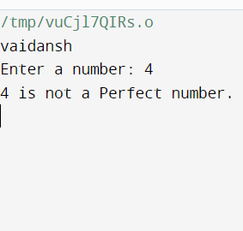

Programme-55

Write a C program to print all Perfect numbers between 1 to n

INPUT

#include <stdio.h>

void printVaidansh() {

printf("vaidansh\n");

}

int isPerfect(int num) {

int sum = 0;

for (int i = 1; i <= num / 2; ++i) {

if (num % i == 0) {

sum += i;

}

}

// Check if the number is Perfect

if (sum == num) {

return 1; // It is a Perfect number

} else {

return 0; // It is not a Perfect number

}

}

int main() {

// Print "vaidansh"

printVaidansh();

// Get input from user

int n;

printf("Enter a number: ");

scanf("%d", &n);

printf("Perfect numbers between 1 to %d are: ", n);

// Check and print Perfect numbers between 1 to n

for (int i = 1; i <= n; ++i) {

if (isPerfect(i)) {

printf("%d ", i);

}

}

printf("\n");

return 0;

}

OUTPUT

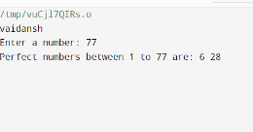

Programme-56

Write a C program to check whether a number is Strong number or not

INPUT

#include <stdio.h>

void printVaidansh() {

printf("vaidansh\n");

}

int factorial(int n) {

if (n == 0 || n == 1) {

return 1;

} else {

return n * factorial(n - 1);

}

}

int isStrongNumber(int num) {

int originalNum, remainder, sum = 0;

originalNum = num;

while (originalNum != 0) {

remainder = originalNum % 10;

sum += factorial(remainder);

originalNum /= 10;

}

// Check if the number is a Strong number

if (sum == num) {

return 1; // It is a Strong number

} else {

return 0; // It is not a Strong number

}

}

int main() {

// Print "vaidansh"

printVaidansh();

// Get input from user

int number;

printf("Enter a number: ");

scanf("%d", &number);

// Check if the number is a Strong number

if (isStrongNumber(number)) {

printf("%d is a Strong number.\n", number);

} else {

printf("%d is not a Strong number.\n", number);

}

return 0;

}

OUTPUT

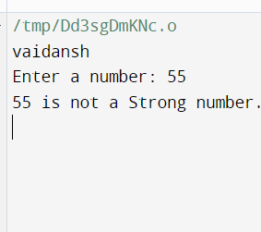

Programme-57

Write a C program to print all Strong numbers between 1 to n

INPUT

#include <stdio.h>

void printVaidansh() {

printf("vaidansh\n");

}

int factorial(int n) {

if (n == 0 || n == 1) {

return 1;

} else {

return n * factorial(n - 1);

}

}

int isStrongNumber(int num) {

int originalNum, remainder, sum = 0;

originalNum = num;

while (originalNum != 0) {

remainder = originalNum % 10;

sum += factorial(remainder);

originalNum /= 10;

}

// Check if the number is a Strong number

if (sum == num) {

return 1; // It is a Strong number

} else {

return 0; // It is not a Strong number

}

}

int main() {

// Print "vaidansh"

printVaidansh();

// Get input from user

int n;

printf("Enter a number: ");

scanf("%d", &n);

printf("Strong numbers between 1 to %d are: ", n);

// Check and print Strong numbers between 1 to n

for (int i = 1; i <= n; ++i) {

if (isStrongNumber(i)) {

printf("%d ", i);

}

}

printf("\n");

return 0;

}

OUTPUT

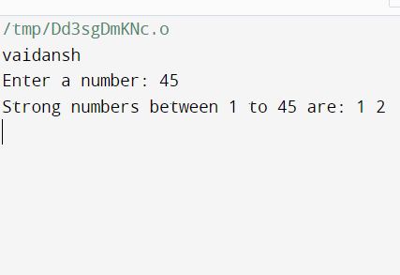

Programme-58

Write a C program to print Fibonacci series up to n terms

INPUT

#include <stdio.h>

void printVaidansh() {

printf("vaidansh\n");

}

void generateFibonacci(int n) {

int first = 0, second = 1, next;

printf("Fibonacci series up to %d terms: ", n);

for (int i = 0; i < n; ++i) {

if (i <= 1) {

next = i;

} else {

next = first + second;

first = second;

second = next;

}

printf("%d ", next);

}

printf("\n");

}

int main() {

// Print "vaidansh"

printVaidansh();

// Get input from user

int n;

printf("Enter the number of terms: ");

scanf("%d", &n);

// Generate and print Fibonacci series up to n terms

generateFibonacci(n);

return 0;

}

OUTPUT

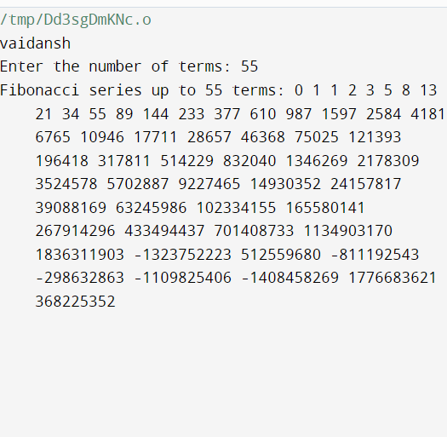

Programme-59

Write a C program to find one's complement of a binary number

INPUT

#include <stdio.h>

#include <string.h>

void printVaidansh() {

printf("vaidansh\n");

}

void onesComplement(char binaryNumber[]) {

int length = strlen(binaryNumber);

printf("One's complement of %s is: ", binaryNumber);

for (int i = 0; i < length; ++i) {

if (binaryNumber[i] == '0') {

printf("1");

} else if (binaryNumber[i] == '1') {

printf("0");

} else {

printf("Invalid input! Please enter a binary number.");

return;

}

}

printf("\n");

}

int main() {

// Print "vaidansh"

printVaidansh();

// Get input from user

char binaryNumber[100];

printf("Enter a binary number: ");

scanf("%s", binaryNumber);

// Find and print one's complement

onesComplement(binaryNumber);

return 0;

}

OUTPUT

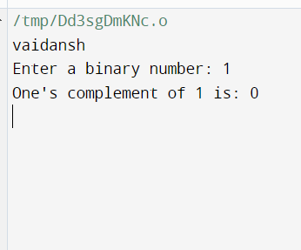

Programme-60

Write a C program to find two's complement of a binary number

INPUT

#include <stdio.h>

#include <string.h>

void printVaidansh() {

printf("vaidansh\n");

}

void onesComplement(char binaryNumber[]) {

int length = strlen(binaryNumber);

for (int i = 0; i < length; ++i) {

if (binaryNumber[i] == '0') {

binaryNumber[i] = '1';

} else if (binaryNumber[i] == '1') {

binaryNumber[i] = '0';

} else {

printf("Invalid input! Please enter a binary number.\n");

return;

}

}

}

void twosComplement(char binaryNumber[]) {

int length = strlen(binaryNumber);

int carry = 1;

// Calculate one's complement

onesComplement(binaryNumber);

// Add 1 to one's complement to get two's complement

for (int i = length - 1; i >= 0; --i) {

if (binaryNumber[i] == '1' && carry == 1) {

binaryNumber[i] = '0';

} else if (binaryNumber[i] == '0' && carry == 1) {

binaryNumber[i] = '1';

carry = 0;

}

}

printf("Two's complement is: %s\n", binaryNumber);

}

int main() {

// Print "vaidansh"

printVaidansh();

// Get input from user

char binaryNumber[100];

printf("Enter a binary number: ");

scanf("%s", binaryNumber);

// Find and print two's complement

twosComplement(binaryNumber);

return 0;

}

OUTPUT



Programme-61

Write a C program to convert Binary to Octal number system

INPUT

#include <stdio.h>

#include <math.h>

void printVaidansh() {

printf("vaidansh\n");

}

int binaryToDecimal(int binaryNumber) {

int decimalNumber = 0, i = 0, remainder;

while (binaryNumber != 0) {

remainder = binaryNumber % 10;

binaryNumber /= 10;

decimalNumber += remainder * pow(2, i);

++i;

}

return decimalNumber;

}

int decimalToOctal(int decimalNumber) {

int octalNumber = 0, i = 1;

while (decimalNumber != 0) {

octalNumber += (decimalNumber % 8) * i;

decimalNumber /= 8;

i *= 10;

}

return octalNumber;

}

int main() {

// Print "vaidansh"

printVaidansh();

// Get input from user

int binaryNumber;

printf("Enter a binary number: ");

scanf("%d", &binaryNumber);

// Convert binary to octal

int decimalNumber = binaryToDecimal(binaryNumber);

int octalNumber = decimalToOctal(decimalNumber);

printf("Octal equivalent: %d\n", octalNumber);

return 0;

}

OUTPUT

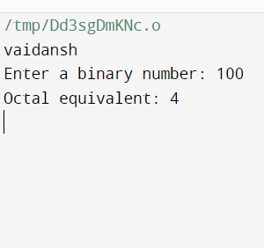

Programme-62

Write a C program to convert Binary to Decimal number system

INPUT

#include <stdio.h>

#include <math.h>

void printVaidansh() {

printf("vaidansh\n");

}

int binaryToDecimal(int binaryNumber) {

int decimalNumber = 0, i = 0, remainder;

while (binaryNumber != 0) {

remainder = binaryNumber % 10;

binaryNumber /= 10;

decimalNumber += remainder * pow(2, i);

++i;

}

return decimalNumber;

}

int main() {

// Print "vaidansh"

printVaidansh();

// Get input from user

int binaryNumber;

printf("Enter a binary number: ");

scanf("%d", &binaryNumber);

// Convert binary to decimal

int decimalNumber = binaryToDecimal(binaryNumber);

printf("Decimal equivalent: %d\n", decimalNumber);

return 0;

}

OUTPUT

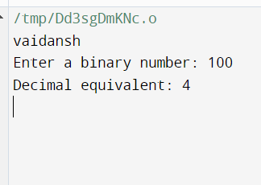

Programme-63

Write a C program to convert Binary to Hexadecimal number system.

INPUT

#include <stdio.h>

#include <math.h>

// Function to convert binary to decimal

int binaryToDecimal(long long binary) {

int decimalNumber = 0, i = 0, remainder;

while (binary != 0) {

remainder = binary % 10;

binary /= 10;

decimalNumber += remainder * pow(2, i);

++i;

}

return decimalNumber;

}

// Function to convert decimal to hexadecimal

void decimalToHexadecimal(int decimalNumber) {

char hexadecimalNumber[50];

int i = 0;

while (decimalNumber != 0) {

int remainder = decimalNumber % 16;

if (remainder < 10) {

hexadecimalNumber[i] = remainder + 48;

} else {

hexadecimalNumber[i] = remainder + 55;

}

++i;

decimalNumber /= 16;

}

printf("Hexadecimal number: ");

for (int j = i - 1; j >= 0; --j) {

printf("%c", hexadecimalNumber[j]);

}

printf("\n");

}

int main() {

// Print "vaidansh"

printf("vaidansh\n");

// Input binary number from the user

long long binary;

printf("Enter a binary number: ");

scanf("%lld", &binary);

// Convert binary to decimal

int decimalNumber = binaryToDecimal(binary);

// Convert decimal to hexadecimal and print the result

decimalToHexadecimal(decimalNumber);

return 0;

}

OUTPUT

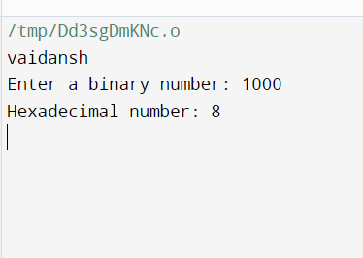

Programme-64

Write a C program to convert Octal to Binary number system

INPUT

#include <stdio.h>

// Function to convert octal to binary

void octalToBinary(int octalNumber) {

int binaryNumber = 0, decimalNumber = 0, i = 0;

// Convert octal to decimal

while(octalNumber != 0) {

decimalNumber += (octalNumber % 10) * pow(8, i);

++i;

octalNumber /= 10;

}

i = 1;

// Convert decimal to binary

while (decimalNumber != 0) {

binaryNumber += (decimalNumber % 2) * i;

decimalNumber /= 2;

i *= 10;

}

printf("Binary number: %d\n", binaryNumber);

}

int main() {

// Print "vaidansh"

printf("vaidansh\n");

// Input octal number from the user

int octalNumber;

printf("Enter an octal number: ");

scanf("%d", &octalNumber);

// Convert octal to binary and print the result

octalToBinary(octalNumber);

return 0;

}

OUTPUT

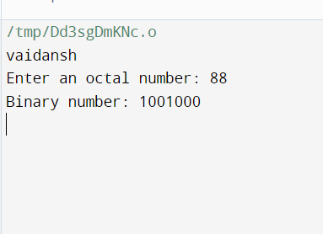

Programme-65

Write a C program to convert Octal to Decimal number system

INPUT

#include <stdio.h>

#include <math.h>

// Function to convert octal to decimal

int octalToDecimal(int octalNumber) {

int decimalNumber = 0, i = 0;

while (octalNumber != 0) {

decimalNumber += (octalNumber % 10) * pow(8, i);

++i;

octalNumber /= 10;

}

return decimalNumber;

}

int main() {

// Print "vaidansh"

printf("vaidansh\n");

// Input octal number from the user

int octalNumber;

printf("Enter an octal number: ");

scanf("%d", &octalNumber);

// Convert octal to decimal and print the result

int decimalNumber = octalToDecimal(octalNumber);

printf("Decimal number: %d\n", decimalNumber);

return 0;

}

OUTPUT

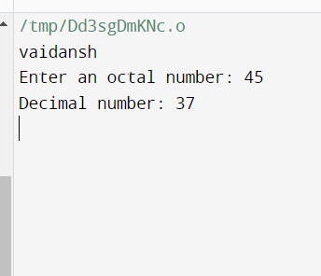

Programme-66

Write a C program to convert Octal to Hexadecimal number system

INPUT

#include <stdio.h>

#include <math.h>

// Function to convert octal to decimal

int octalToDecimal(int octalNumber) {

int decimalNumber = 0, i = 0;

while (octalNumber != 0) {

decimalNumber += (octalNumber % 10) * pow(8, i);

++i;

octalNumber /= 10;

}

return decimalNumber;

}

// Function to convert decimal to hexadecimal

void decimalToHexadecimal(int decimalNumber) {

char hexadecimalNumber[50];

int i = 0;

while (decimalNumber != 0) {

int remainder = decimalNumber % 16;

if (remainder < 10) {

hexadecimalNumber[i] = remainder + 48;

} else {

hexadecimalNumber[i] = remainder + 55;

}

++i;

decimalNumber /= 16;

}

printf("Hexadecimal number: ");

for (int j = i - 1; j >= 0; --j) {

printf("%c", hexadecimalNumber[j]);

}

printf("\n");

}

int main() {

// Print "vaidansh"

printf("vaidansh\n");

// Input octal number from the user

int octalNumber;

printf("Enter an octal number: ");

scanf("%d", &octalNumber);

// Convert octal to decimal

int decimalNumber = octalToDecimal(octalNumber);

// Convert decimal to hexadecimal and print the result

decimalToHexadecimal(decimalNumber);

return 0;

}

OUTPUT

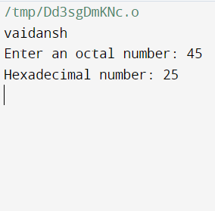

Programme-67

Write a C program to convert Decimal to Binary number system

INPUT

#include <stdio.h>

// Function to convert decimal to binary

void decimalToBinary(int decimalNumber) {

int binaryNumber[1000];

int i = 0;

while (decimalNumber > 0) {

binaryNumber[i] = decimalNumber % 2;

decimalNumber = decimalNumber / 2;

i++;

}

printf("Binary number: ");

for (int j = i - 1; j >= 0; j--) {

printf("%d", binaryNumber[j]);

}

printf("\n");

}

int main() {

// Print "vaidansh"

printf("vaidansh\n");

// Input decimal number from the user

int decimalNumber;

printf("Enter a decimal number: ");

scanf("%d", &decimalNumber);

// Convert decimal to binary and print the result

decimalToBinary(decimalNumber);

return 0;

}

OUTPUT

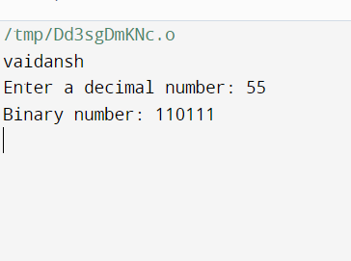

Programme-68

Write a C program to convert Decimal to Octal number system

INPUT

#include <stdio.h>

// Function to convert decimal to octal

void decimalToOctal(int decimalNumber) {

int octalNumber[1000];

int i = 0;

while (decimalNumber > 0) {

octalNumber[i] = decimalNumber % 8;

decimalNumber = decimalNumber / 8;

i++;

}

printf("Octal number: ");

for (int j = i - 1; j >= 0; j--) {

printf("%d", octalNumber[j]);

}

printf("\n");

}

int main() {

// Print "vaidansh"

printf("vaidansh\n");

// Input decimal number from the user

int decimalNumber;

printf("Enter a decimal number: ");

scanf("%d", &decimalNumber);

// Convert decimal to octal and print the result

decimalToOctal(decimalNumber);

return 0;

}

OUTPUT

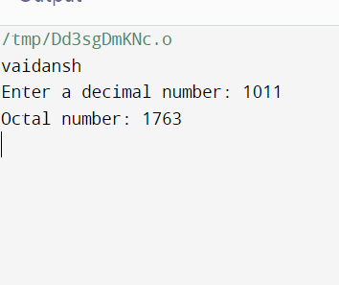

Programme-69

Write a C program to convert Decimal to Hexadecimal number system

INPUT

#include <stdio.h>

int main() {

// Print the name "vaidansh"

printf("vaidansh\n");

// Convert Decimal to Hexadecimal

int decimalNumber;

printf("Enter a decimal number: ");

scanf("%d", &decimalNumber);

// Convert decimal to hexadecimal

printf("Hexadecimal equivalent: %X\n", decimalNumber);

return 0;

}

OUTPUT

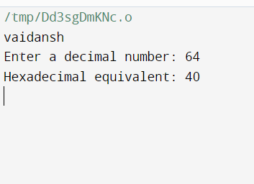

Programme-70

Write a C program to convert Hexadecimal to Binary number system

INPUT

#include <stdio.h>

#include <string.h>

// Function to convert hexadecimal digit to binary

void hexDigitToBinary(char hexDigit) {

switch(hexDigit) {

case '0':

printf("0000");

break;

case '1':

printf("0001");

break;

case '2':

printf("0010");

break;

case '3':

printf("0011");

break;

case '4':

printf("0100");

break;

case '5':

printf("0101");

break;

case '6':

printf("0110");

break;

case '7':

printf("0111");

break;

case '8':

printf("1000");

break;

case '9':

printf("1001");

break;

case 'A':

case 'a':

printf("1010");

break;

case 'B':

case 'b':

printf("1011");

break;

case 'C':

case 'c':

printf("1100");

break;

case 'D':

case 'd':

printf("1101");

break;

case 'E':

case 'e':

printf("1110");

break;

case 'F':

case 'f':

printf("1111");

break;

default:

printf("Invalid Hexadecimal Digit!");

}

}

int main() {

// Print the name "vaidansh"

printf("vaidansh\n");

// Convert Hexadecimal to Binary

char hexNumber[20];

printf("Enter a hexadecimal number: ");

scanf("%s", hexNumber);

printf("Binary equivalent: ");

int length = strlen(hexNumber);

for (int i = 0; i < length; ++i) {

hexDigitToBinary(hexNumber[i]);

}

printf("\n");

return 0;

}

OUTPUT

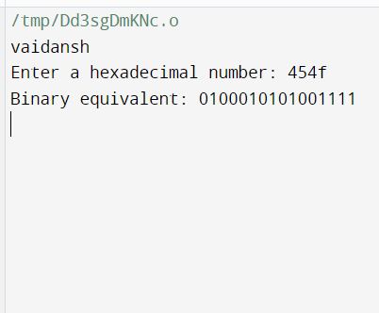

Programme-71

Write a C program to convert Hexadecimal to Octal number system

INPUT

#include <stdio.h>

#include <string.h>

// Function to convert hexadecimal digit to binary

int hexDigitToDecimal(char hexDigit) {

if (hexDigit >= '0' && hexDigit <= '9') {

return hexDigit - '0';

} else if (hexDigit >= 'A' && hexDigit <= 'F') {

return hexDigit - 'A' + 10;

} else if (hexDigit >= 'a' && hexDigit <= 'f') {

return hexDigit - 'a' + 10;

} else {

return -1; // Invalid hexadecimal digit

}

}

// Function to convert hexadecimal to octal

void hexToOctal(char hexNumber[]) {

int decimalNumber = 0;

int octalNumber[100], i = 1, j = 0;

// Convert hexadecimal to decimal

int length = strlen(hexNumber);

for (int k = length - 1; k >= 0; k--) {

int digit = hexDigitToDecimal(hexNumber[k]);

if (digit == -1) {

printf("Invalid Hexadecimal Number!\n");

return;

}

decimalNumber += digit * i;

i *= 16;

}

// Convert decimal to octal

while (decimalNumber != 0) {

octalNumber[j] = decimalNumber % 8;

decimalNumber /= 8;

j++;

}

// Print octal number in reverse order

printf("Octal equivalent: ");

for (int k = j - 1; k >= 0; k--) {

printf("%d", octalNumber[k]);

}

printf("\n");

}

int main() {

// Print the name "vaidansh"

printf("vaidansh\n");

// Convert Hexadecimal to Octal

char hexNumber[20];

printf("Enter a hexadecimal number: ");

scanf("%s", hexNumber);

hexToOctal(hexNumber);

return 0;

}

OUTPUT

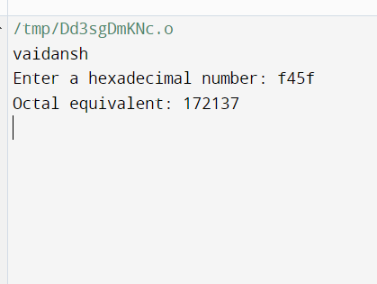

Programme-72

Write a C program to convert Hexadecimal to Decimal number system.

INPUT

#include <stdio.h>

#include <string.h>

#include <math.h>

// Function to convert hexadecimal digit to decimal

int hexDigitToDecimal(char hexDigit) {

if (hexDigit >= '0' && hexDigit <= '9') {

return hexDigit - '0';

} else if (hexDigit >= 'A' && hexDigit <= 'F') {

return hexDigit - 'A' + 10;

} else if (hexDigit >= 'a' && hexDigit <= 'f') {

return hexDigit - 'a' + 10;

} else {

return -1; // Invalid hexadecimal digit

}

}

// Function to convert hexadecimal to decimal

int hexToDecimal(char hexNumber[]) {

int decimalNumber = 0;

int length = strlen(hexNumber);

int power = length - 1;

// Convert hexadecimal to decimal

for (int i = 0; i < length; i++) {

int digit = hexDigitToDecimal(hexNumber[i]);

if (digit == -1) {

printf("Invalid Hexadecimal Number!\n");

return -1;

}

decimalNumber += digit * pow(16, power);

power--;

}

return decimalNumber;

}

int main() {

// Print the name "vaidansh"

printf("vaidansh\n");

// Convert Hexadecimal to Decimal

char hexNumber[20];

printf("Enter a hexadecimal number: ");

scanf("%s", hexNumber);

int decimalNumber = hexToDecimal(hexNumber);

if (decimalNumber != -1) {

printf("Decimal equivalent: %d\n", decimalNumber);

}

return 0;

}

OUTPUT

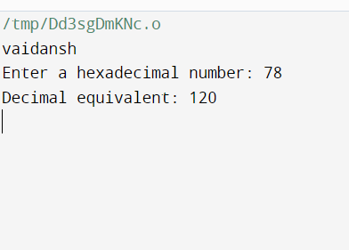

Programme-72

Write a C program to convert Hexadecimal to Decimal number system.

INPUT

#include <stdio.h>

#include <string.h>

#include <math.h>

// Function to convert hexadecimal to decimal

int hexToDecimal(char hex[]) {

int len = strlen(hex);

int decimal = 0;

int base = 1;

for (int i = len - 1; i >= 0; i--) {

int digit;

if (hex[i] >= '0' && hex[i] <= '9') {

digit = hex[i] - '0';

} else if (hex[i] >= 'A' && hex[i] <= 'F') {

digit = hex[i] - 'A' + 10;

} else if (hex[i] >= 'a' && hex[i] <= 'f') {

digit = hex[i] - 'a' + 10;

} else {

// Invalid hexadecimal digit

printf("Invalid hexadecimal number\n");

return -1;

}

decimal += digit * base;

base *= 16;

}

return decimal;

}

int main() {

// Print "vaidansh"

printf("vaidansh\n");

// Convert hexadecimal to decimal

char hex[20];

printf("Enter a hexadecimal number: ");

scanf("%s", hex);

int decimal = hexToDecimal(hex);

if (decimal != -1) {

printf("Decimal equivalent: %d\n", decimal);

}

return 0;

}

OUTPUT

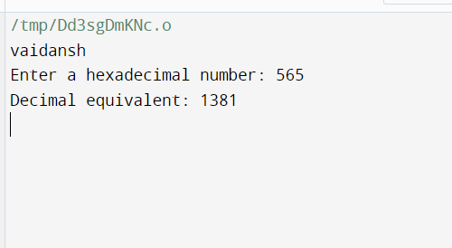

**Prograame-73**

**1. Star pattern programs - Write a C program to print the given star patterns.**

**\***

**\*\*\***

**\*\*\*\*\***

**\*\*\*\*\*\*\***

**\*\*\*\*\*\*\*\*\***

**Pyramid Star Pattern**

**INPUT**

#include <stdio.h>

int main() {

// Print "vaidansh"

printf("vaidansh\n");

// Print star patterns

int i, j, rows;

// Pattern 1: *

printf("Pattern 1:\n");

for(i = 1; i <= 5; ++i) {

printf("*\n");

}

// Pattern 2: ***

printf("Pattern 2:\n");

for(i = 1; i <= 3; ++i) {

for(j = 1; j <= 2*i-1; ++j) {

printf("*");

}

printf("\n");

}

// Pattern 3: *****

printf("Pattern 3:\n");

for(i = 1; i <= 5; ++i) {

for(j = 1; j <= 2*i-1; ++j) {

printf("*");

}

printf("\n");

}

// Pattern 4: *******

printf("Pattern 4:\n");

for(i = 1; i <= 7; ++i) {

for(j = 1; j <= 2*i-1; ++j) {

printf("*");

}

printf("\n");

}

// Pattern 5: *********

printf("Pattern 5:\n");

for(i = 1; i <= 9; ++i) {

for(j = 1; j <= 2*i-1; ++j) {

printf("*");

}

printf("\n");

}

// Pyramid Star Pattern

printf("Pyramid Star Pattern:\n");

rows = 5;

for(i = 1; i <= rows; ++i) {

for(j = 1; j <= rows - i; ++j) {

printf(" ");

}

for(j = 1; j <= 2*i - 1; ++j) {

printf("*");

}

printf("\n");

}

return 0;

}

**OUTPUT**

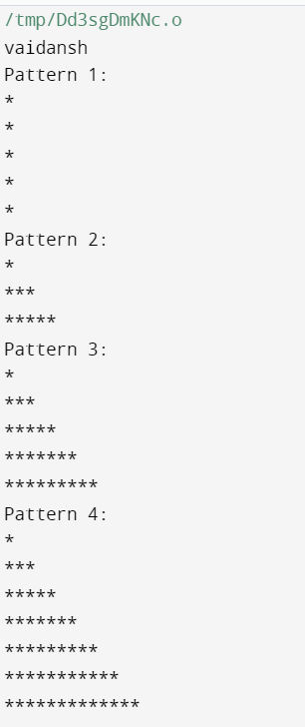

**\***

**\* \***

**\* \***

**\* \***

**\*\*\*\*\*\*\*\*\***

**Hollow Pyramid Star Pattern**

**INPUT**

#include <stdio.h>

int main() {

// Print "vaidansh"

printf("vaidansh\n");

// Hollow Pyramid Star Pattern

int i, j, rows;

printf("Hollow Pyramid Star Pattern:\n");

rows = 5;

// Outer loop for number of rows

for (i = 1; i <= rows; ++i) {

// Inner loop for spaces

for (j = 1; j <= rows - i; ++j) {

printf(" ");

}

// Inner loop for stars

for (j = 1; j <= 2 * i - 1; ++j) {

// Print star for the first row or last row

// or if the column is the first or last of the row

if (i == 1 || i == rows || j == 1 || j == 2 * i - 1) {

printf("*");

} else {

printf(" ");

}

}

// Move to the next line

printf("\n");

}

return 0;

}

**OUTPUT**

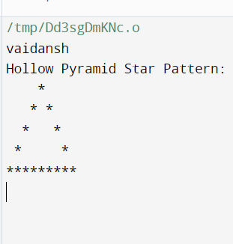

**\*\*\*\*\*\*\*\*\***

**\*\*\*\*\*\*\***

**\*\*\*\*\***

**\*\*\***

**\***

**Inverted Pyramid Star Pattern**

**INPUT**

#include <stdio.h>

int main() {

// Print "vaidansh"

printf("vaidansh\n");

// Inverted Pyramid Star Pattern

int i, j, rows;

printf("Inverted Pyramid Star Pattern:\n");

rows = 5;

// Outer loop for number of rows

for (i = rows; i >= 1; --i) {

// Inner loop for spaces

for (j = 1; j <= rows - i; ++j) {

printf(" ");

}

// Inner loop for stars

for (j = 1; j <= 2 * i - 1; ++j) {

printf("*");

}

// Move to the next line

printf("\n");

}

return 0**;**

**}**

**OUTPUT**

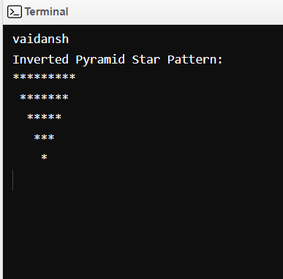

**\*\*\*\*\*\*\*\*\***

**\* \***

**\* \***

**\* \***

**\***

**Hollow Inverted Pyramid Star Pattern**

**INPUT**

#include <stdio.h>

int main() {

// Print "vaidansh"

printf("vaidansh\n");

// Hollow Inverted Pyramid Star Pattern

int i, j, rows;

printf("Hollow Inverted Pyramid Star Pattern:\n");

rows = 5;

// Outer loop for number of rows

for (i = rows; i >= 1; --i) {

// Inner loop for spaces

for (j = 1; j <= rows - i; ++j) {

printf(" ");

}

// Inner loop for stars

for (j = 1; j <= 2 * i - 1; ++j) {

// Print star for the first and last columns or

// if it's the first or last row

if (j == 1 || j == 2 * i - 1 || i == rows) {

printf("*");

} else {

printf(" ");

}

}

// Move to the next line

printf("\n");

}

return 0;

}

**OUTPUT**

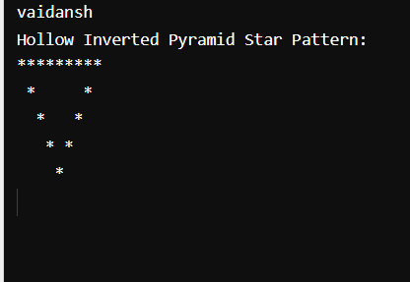

**\*\*\*\*\***

**\*\*\*\***

**\*\*\***

**\*\***

**\***

**Half Diamond Star Pattern**

**INPUT**

#include <stdio.h>

int main() {

// Print "vaidansh"

printf("vaidansh\n");

// Half Diamond Star Pattern

int i, j, rows;

printf("Half Diamond Star Pattern:\n");

rows = 5;

// Upper half of the diamond

for (i = 1; i <= rows; ++i) {

for (j = 1; j <= i; ++j) {

printf("*");

}

printf("\n");

}

// Lower half of the diamond

for (i = rows - 1; i >= 1; --i) {

for (j = 1; j <= i; ++j) {

printf("*");

}

printf("\n");

}

return 0;

}

**OUTPUT**

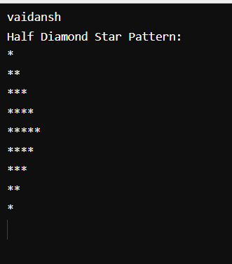

**\***

**\*\***

**\*\*\***

**\*\*\*\***

**\*\*\*\*\***

**\*\*\*\***

**\*\*\***

**\*\***

**\***

Mirrored Half Diamond Star Pattern

INPUT

#include <stdio.h>

int main() {

// Print "vaidansh"

printf("vaidansh\n");

// Mirrored Half Diamond Star Pattern

int i, j, rows;

printf("Mirrored Half Diamond Star Pattern:\n");

rows = 5;

// Upper half of the mirrored diamond

for (i = 1; i <= rows; ++i) {

// Spaces before the stars

for (j = 1; j <= rows - i; ++j) {

printf(" ");

}

// Stars

for (j = 1; j <= i; ++j) {

printf("*");

}

// Move to the next line

printf("\n");

}

// Lower half of the mirrored diamond

for (i = rows - 1; i >= 1; --i) {

// Spaces before the stars

for (j = 1; j <= rows - i; ++j) {

printf(" ");

}

// Stars

for (j = 1; j <= i; ++j) {

printf("*");

}

// Move to the next line

printf("\n");

}

return 0;

}

OUTPUT

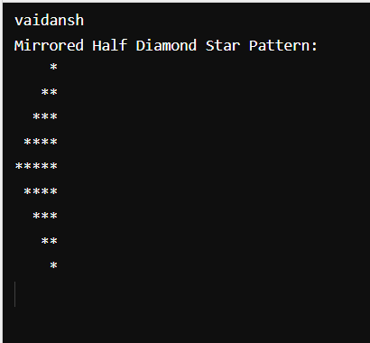

Programme-74

**Write a C program to print the given number patterns**

**Square number patterns**

11111

11111

11111

11111

INPUT

#include <stdio.h>

int main() {

printf("Vaidansh\n");

int rows, cols;

// Number of rows and columns in the square pattern

rows = 5;

cols = 5;

// Printing square number pattern

for (int i = 1; i <= rows; ++i) {

for (int j = 1; j <= cols; ++j) {

printf("1");

}

printf("\n");

}

return 0;

}

OUTPUT

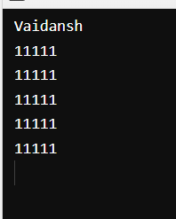

Number pattern 1

11111

00000

11111

00000

11111

INPUT

#include <stdio.h>

int main() {

printf("vaidansh Thapliyal is great\n");

int rows = 5;

int cols = 5;

// Printing number pattern

for (int i = 1; i <= rows; ++i) {

for (int j = 1; j <= cols; ++j) {

if (i % 2 == 1) {

printf("1");

} else {

printf("0");

}

}

printf("\n");

}

return 0;

}

OUTPUT

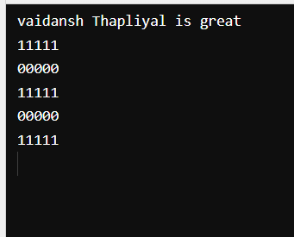

**Number pattern 2**

**01010**

**01010**

**01010**

01010

INPUT

#include <stdio.h>

int main() {

printf("Vaidansh\n");

int rows = 4;

int cols = 5;

// Printing number pattern

for (int i = 1; i <= rows; ++i) {

for (int j = 1; j <= cols; ++j) {

if (j % 2 == 0) {

printf("1");

} else {

printf("0");

}

}

printf("\n");

}

return 0;

}

OUTPUT

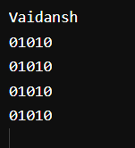

Number pattern 3

11111

10001

10001

10001

11111

**INPUT**

#include <stdio.h>

int main() {

printf("Vaidansh\n");

int rows = 5;

int cols = 5;

// Printing number pattern

for (int i = 1; i <= rows; ++i) {

for (int j = 1; j <= cols; ++j) {

if (i == 1 || i == rows || j == 1 || j == cols) {

printf("1");

} else {

printf("0");

}

}

printf("\n");

}

return 0;

}

**OUTPUT**

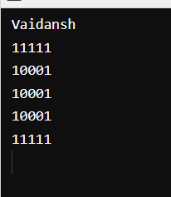

Number pattern 4

11111

11111

11011

11111

11111

**INPUT**

#include <stdio.h>

int main() {

printf("Vaidansh\n");

int rows = 5;

int cols = 5;

// Printing number pattern

for (int i = 1; i <= rows; ++i) {

for (int j = 1; j <= cols; ++j) {

if (i == 3 && j == 3) {

printf("0");

} else {

printf("1");

}

}

printf("\n");

}

return 0;

}

**OUTPUT**

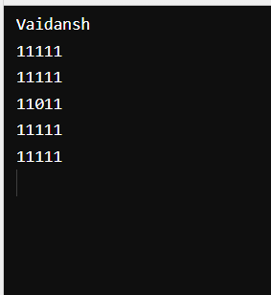

Number pattern 5

10101

01010

10101

01010

10101

INPUT

#include <stdio.h>

int main() {

printf("Vaidansh\n");

int rows = 5;

int cols = 5;

// Printing number pattern

for (int i = 1; i <= rows; ++i) {

for (int j = 1; j <= cols; ++j) {

if ((i + j) % 2 == 0) {

printf("1");

} else {

printf("0");

}

}

printf("\n");

}

return 0;

}

OUTPUT

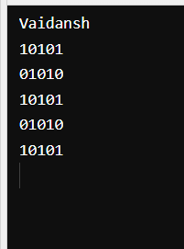

**Programme-75**

**Write a C program to find maximum between two numbers**

**INPUT**

#include <stdio.h>

int main() {

// Print "vaidansh"

printf("vaidansh\n");

// Find the maximum between two numbers

int num1, num2;

// Input two numbers

printf("Enter first number: ");

scanf("%d", &num1);

printf("Enter second number: ");

scanf("%d", &num2);

// Check and print the maximum number

if (num1 > num2) {

printf("Maximum number is: %d\n", num1);

} else {

printf("Maximum number is: %d\n", num2);

}

return 0;

}

**OUTPUT**

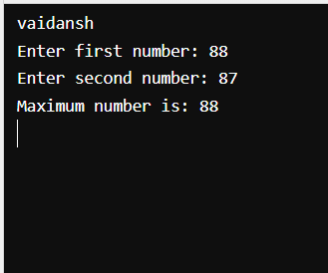

**Programme-76**

**Write a C program to find maximum between three numbers**

**INPUT**

#include <stdio.h>

int main() {

// Print "vaidansh"

printf("vaidansh\n");

// Find the maximum among three numbers

int num1, num2, num3;

// Input three numbers

printf("Enter first number: ");

scanf("%d", &num1);

printf("Enter second number: ");

scanf("%d", &num2);

printf("Enter third number: ");

scanf("%d", &num3);

// Check and print the maximum number

if (num1 >= num2 && num1 >= num3) {

printf("Maximum number is: %d\n", num1);

} else if (num2 >= num1 && num2 >= num3) {

printf("Maximum number is: %d\n", num2);

} else {

printf("Maximum number is: %d\n", num3);

}

return 0;

}

**OUTPUT**

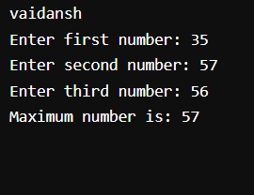

**Programme-77**

**Write a C program to check whether a number is negative, positive or zero**

**INPUT**

#include <stdio.h>

int main() {

// Print "vaidansh"

printf("vaidansh\n");

// Check whether a number is negative, positive, or zero

int num;

// Input a number

printf("Enter a number: ");

scanf("%d", &num);

// Check and print whether the number is negative, positive, or zero

if (num < 0) {

printf("The number is negative.\n");

} else if (num > 0) {

printf("The number is positive.\n");

} else {

printf("The number is zero.\n");

}

return 0;

}

**OUTPUT**

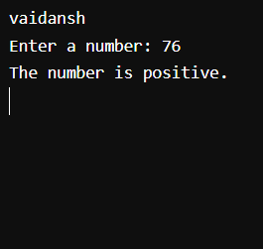

**Programme-78**

**Write a C program to check whether a number is divisible by 5 and 11 or not**

**INPUT**

#include <stdio.h>

int main() {

// Print "vaidansh"

printf("vaidansh\n");

// Check whether a number is divisible by 5 and 11

int num;

// Input a number

printf("Enter a number: ");

scanf("%d", &num);

// Check and print whether the number is divisible by 5 and 11 or not

if (num % 5 == 0 && num % 11 == 0) {

printf("The number is divisible by both 5 and 11.\n");

} else {

printf("The number is not divisible by both 5 and 11.\n");

}

return 0;

}

**OUTPUT**

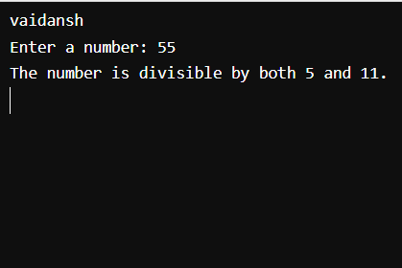

**Programme-79**

**Write a C program to check whether a number is even or odd**

**INPUT**

#include <stdio.h>

int main() {

// Print "vaidansh"

printf("vaidansh\n");

// Check whether a number is even or odd

int num;

// Input a number

printf("Enter a number: ");

scanf("%d", &num);

// Check and print whether the number is even or odd

if (num % 2 == 0) {

printf("The number is even.\n");

} else {

printf("The number is odd.\n");

}

return 0;

}

**OUTPUT**

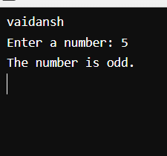

**Programme-80**

**Write a C program to check whether a year is leap year or not**

**INPUT**

#include <stdio.h>

int main() {

// Print "vaidansh"

printf("vaidansh\n");

// Check whether a year is a leap year

int year;

// Input a year

printf("Enter a year: ");

scanf("%d", &year);

// Check and print whether the year is a leap year or not

if ((year % 400 == 0) || ((year % 4 == 0) && (year % 100 != 0))) {

printf("%d is a leap year.\n", year);

} else {

printf("%d is not a leap year.\n", year);

}

return 0;

}

**OUTPUT**

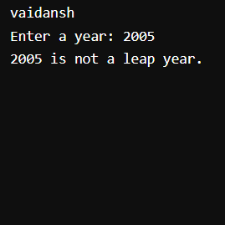

**Programme-81**

**Write a C program to check whether a character is alphabet or not**

**INPUT**

#include <stdio.h>

int main() {

// Print "vaidansh"

printf("vaidansh\n");

// Check whether a character is an alphabet

char ch;

// Input a character

printf("Enter a character: ");

scanf(" %c", &ch); // Note the space before %c to consume any leading whitespace or newline character

// Check and print whether the character is an alphabet or not

if ((ch >= 'a' && ch <= 'z') || (ch >= 'A' && ch <= 'Z')) {

printf("%c is an alphabet.\n", ch);

} else {

printf("%c is not an alphabet.\n", ch);

}

return 0;

}

**OUTPUT**

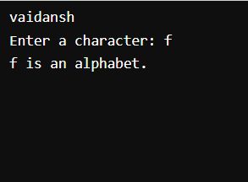

**Programme-82**

**Write a C program to input any alphabet and check whether it is vowel or consonant**

**INPUT**

#include <stdio.h>

int main() {

// Print "vaidansh"

printf("vaidansh\n");

// Check whether a character is a vowel or consonant

char ch;

// Input a character

printf("Enter a character: ");

scanf(" %c", &ch); // Note the space before %c to consume any leading whitespace or newline character

// Check and print whether the character is a vowel or consonant

if ((ch >= 'a' && ch <= 'z') || (ch >= 'A' && ch <= 'Z')) {

// Check if the character is a vowel

if (ch == 'a' || ch == 'e' || ch == 'i' || ch == 'o' || ch == 'u' ||

ch == 'A' || ch == 'E' || ch == 'I' || ch == 'O' || ch == 'U') {

printf("%c is a vowel.\n", ch);

} else {

printf("%c is a consonant.\n", ch);

}

} else {

printf("%c is not a valid alphabet.\n", ch);

}

return 0;

}

**OUTPUT**

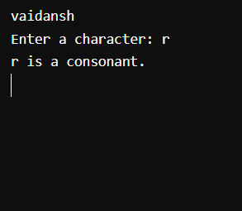

**Programme-83**

**Write a C program to check whether a character is uppercase or lowercase alphabet**

**INPUT**

#include <stdio.h>

int main() {

// Print "vaidansh"

printf("vaidansh\n");

// Check whether a character is uppercase or lowercase alphabet

char ch;

// Input a character

printf("Enter a character: ");

scanf(" %c", &ch); // Note the space before %c to consume any leading whitespace or newline character

// Check and print whether the character is uppercase or lowercase alphabet

if (ch >= 'A' && ch <= 'Z') {

printf("%c is an uppercase alphabet.\n", ch);

} else if (ch >= 'a' && ch <= 'z') {

printf("%c is a lowercase alphabet.\n", ch);

} else {

printf("%c is not an alphabet.\n", ch);

}

return 0;

}

**OUTPUT**

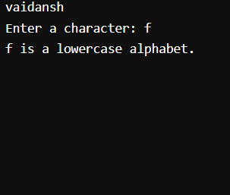

**Programme-84**

**Write a C program to input week number and print week day**

**INPUT**

#include <stdio.h>

int main() {

// Print "vaidansh"

printf("vaidansh\n");

// Input week number

int weekNumber;

printf("Enter week number (1 to 7): ");

scanf("%d", &weekNumber);

// Determine and print the weekday based on the input week number using if-else statements

if (weekNumber == 1) {

printf("Day %d of the week is: Sunday\n", weekNumber);

} else if (weekNumber == 2) {

printf("Day %d of the week is: Monday\n", weekNumber);

} else if (weekNumber == 3) {

printf("Day %d of the week is: Tuesday\n", weekNumber);

} else if (weekNumber == 4) {

printf("Day %d of the week is: Wednesday\n", weekNumber);

} else if (weekNumber == 5) {

printf("Day %d of the week is: Thursday\n", weekNumber);

} else if (weekNumber == 6) {

printf("Day %d of the week is: Friday\n", weekNumber);

} else if (weekNumber == 7) {

printf("Day %d of the week is: Saturday\n", weekNumber);

} else {

printf("Invalid week number. Please enter a number between 1 to 7.\n");

}

return 0;

}

**OUTPUT**

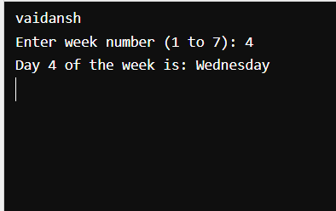

**Programme-85**

**Write a C program to input month number and print number of days in that month**

**INPUT**

#include <stdio.h>

int main() {

// Print "vaidansh"

printf("vaidansh\n");

// Input month number

int monthNumber;

printf("Enter month number (1 to 12): ");

scanf("%d", &monthNumber);

// Determine and print the number of days in the input month number using if-else statements

if (monthNumber == 1 || monthNumber == 3 || monthNumber == 5 || monthNumber == 7 || monthNumber == 8 || monthNumber == 10 || monthNumber == 12) {

printf("Number of days in month %d: 31 days\n", monthNumber);

} else if (monthNumber == 4 || monthNumber == 6 || monthNumber == 9 || monthNumber == 11) {

printf("Number of days in month %d: 30 days\n", monthNumber);

} else if (monthNumber == 2) {

printf("Number of days in month %d: 28 or 29 days (depending on leap year)\n", monthNumber);

} else {

printf("Invalid month number. Please enter a number between 1 to 12.\n");

}

return 0;

}

**OUTPUT**

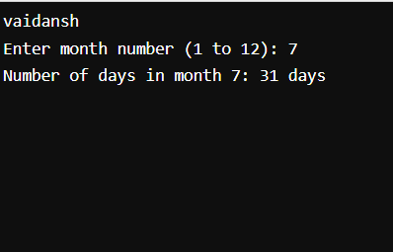

**Programme-86**

**Write a C program to count total number of notes in given amount**

**INPUT**

#include <stdio.h>

int main() {

// Print "vaidansh"

printf("vaidansh\n");

// Input amount

int amount;

printf("Enter the amount: ");

scanf("%d", &amount);

// Variables to store count of different notes

int notes500, notes100, notes50, notes20, notes10, notes5, notes1;

notes500 = notes100 = notes50 = notes20 = notes10 = notes5 = notes1 = 0;

// Calculate number of notes

if (amount >= 500) {

notes500 = amount / 500;

amount %= 500;

}

if (amount >= 100) {

notes100 = amount / 100;

amount %= 100;

}

if (amount >= 50) {

notes50 = amount / 50;

amount %= 50;

}

if (amount >= 20) {

notes20 = amount / 20;

amount %= 20;

}

if (amount >= 10) {

notes10 = amount / 10;

amount %= 10;

}

if (amount >= 5) {

notes5 = amount / 5;

amount %= 5;

}

if (amount >= 1) {

notes1 = amount;

}

// Print the number of notes

printf("Number of 500 notes: %d\n", notes500);

printf("Number of 100 notes: %d\n", notes100);

printf("Number of 50 notes: %d\n", notes50);

printf("Number of 20 notes: %d\n", notes20);

printf("Number of 10 notes: %d\n", notes10);

printf("Number of 5 notes: %d\n", notes5);

printf("Number of 1 notes: %d\n", notes1);

return 0;

}

**OUTPUT**

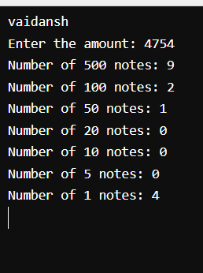

**Programme-87**

**Write a C program to input month number and print number of days in that month**

**INPUT**

#include <stdio.h>

int main() {

int month;

// Prompt user for input

printf("Enter the month number: ");

scanf("%d", &month);

// Check and print the number of days based on the month number

if (month == 1 || month == 3 || month == 5 || month == 7 || month == 8 || month == 10 || month == 12) {

printf("Number of days in the month: 31\n");

} else if (month == 4 || month == 6 || month == 9 || month == 11) {

printf("Number of days in the month: 30\n");

} else if (month == 2) {

printf("Number of days in the month: 28 or 29 (leap year)\n");

} else {

printf("Invalid month number\n");

}

return 0;

}

**OUTPUT**

**Screenshot (1042).png**

**Programme-88**

**Write a C program to count total 0number of notes in given amount**

**INPUT**

#include <stdio.h>

int main() {

int amount, count = 0;

// Prompt user for input

printf("Enter the amount: ");

scanf("%d", &amount);

// Calculate the number of 0 notes in the given amount

if (amount >= 100) {

count = amount / 100;

amount = amount % 100;

}

// Output "vaidansh" and the count of 0 notes

printf("vaidansh\n");

printf("Number of 0 notes: %d\n", count);

return 0;

}

**OUTPUT**

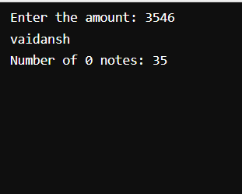

**Programme-89**

**Write a C program to input angles of a triangle and check whether triangle is valid or not**

**INPUT**

#include <stdio.h>

int main() {

int angle1, angle2, angle3;

// Prompt user for input

printf("Enter the first angle of the triangle: ");

scanf("%d", &angle1);

printf("Enter the second angle of the triangle: ");

scanf("%d", &angle2);

printf("Enter the third angle of the triangle: ");

scanf("%d", &angle3);

// Check if the angles form a valid triangle

if (angle1 + angle2 + angle3 == 180 && angle1 > 0 && angle2 > 0 && angle3 > 0) {

printf("vaidansh\n");

printf("The triangle is valid.\n");

} else {

printf("vaidansh\n");

printf("The triangle is not valid.\n");

}

return 0;

}

**OUTPUT**

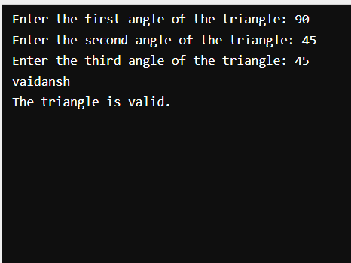

**Programme-90**

**Write a C program to input all sides of a triangle and check whether triangle is valid or not**

**INPUT**

#include <stdio.h>

int main() {

int side1, side2, side3;

// Prompt user for input

printf("Enter the length of the first side of the triangle: ");

scanf("%d", &side1);

printf("Enter the length of the second side of the triangle: ");

scanf("%d", &side2);

printf("Enter the length of the third side of the triangle: ");

scanf("%d", &side3);

// Check if the sides form a valid triangle

if (side1 + side2 > side3 && side1 + side3 > side2 && side2 + side3 > side1 && side1 > 0 && side2 > 0 && side3 > 0) {

printf("vaidansh\n");

printf("The triangle is valid.\n");

} else {

printf("vaidansh\n");

printf("The triangle is not valid.\n");

}

return 0;

}

**OUTPUT**

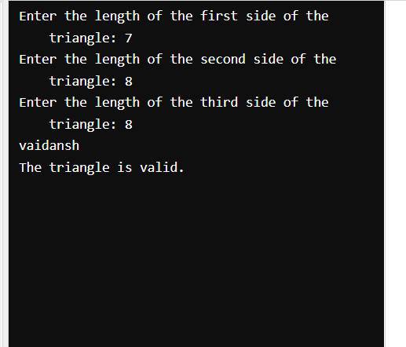

**Programme-91**

**Write a C program to check whether the triangle is equilateral, isosceles or scalene triangle**

**INPUT**

#include <stdio.h>

int main() {

int side1, side2, side3;

// Prompt user for input

printf("Enter the length of the first side of the triangle: ");

scanf("%d", &side1);

printf("Enter the length of the second side of the triangle: ");

scanf("%d", &side2);

printf("Enter the length of the third side of the triangle: ");

scanf("%d", &side3);

// Check the type of triangle

if (side1 == side2 && side2 == side3) {

printf("vaidansh\n");

printf("The triangle is an equilateral triangle.\n");

} else if (side1 == side2 || side1 == side3 || side2 == side3) {

printf("vaidansh\n");

printf("The triangle is an isosceles triangle.\n");

} else {

printf("vaidansh\n");

printf("The triangle is a scalene triangle.\n");

}

return 0;

}

**OUTPUT**

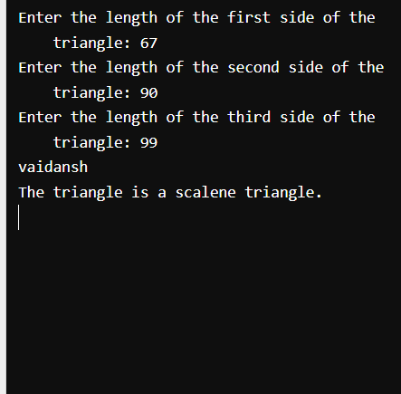

**Programme-92**

**Write a C program to find all roots of a quadratic equation**

**INPUT**

#include <stdio.h>

#include <math.h>

int main() {

printf("vaidansh\n");

// Coefficients of the quadratic equation: ax^2 + bx + c = 0

double a, b, c;

printf("Enter coefficients a, b, and c: ");

scanf("%lf %lf %lf", &a, &b, &c);

// Calculate discriminant

double discriminant = b * b - 4 * a * c;

// Calculate roots

if (discriminant > 0) {

double root1 = (-b + sqrt(discriminant)) / (2 * a);

double root2 = (-b - sqrt(discriminant)) / (2 * a);

printf("Roots are real and different: %.2lf and %.2lf\n", root1, root2);

} else if (discriminant == 0) {

double root = -b / (2 * a);

printf("Roots are real and same: %.2lf\n", root);

} else {

double realPart = -b / (2 * a);

double imaginaryPart = sqrt(-discriminant) / (2 * a);

printf("Roots are complex and different: %.2lf + %.2lfi and %.2lf - %.2lfi\n",

realPart, imaginaryPart, realPart, imaginaryPart);

}

return 0;

}

**OUTPUT**

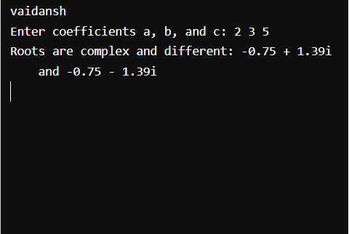

**Programme-93**

**Write a C program to calculate profit or loss**

**INPUT**

#include <stdio.h>

int main() {

// Print "vaidansh"

printf("vaidansh\n");

// Declare variables

float costPrice, sellingPrice, profit, loss;

// Input cost price and selling price from user

printf("Enter the cost price: ");

scanf("%f", &costPrice);

printf("Enter the selling price: ");

scanf("%f", &sellingPrice);

// Calculate profit and loss using if-else construct

if (sellingPrice > costPrice) {

profit = sellingPrice - costPrice;

printf("Profit: %.2f\n", profit);

} else if (sellingPrice < costPrice) {

loss = costPrice - sellingPrice;

printf("Loss: %.2f\n", loss);

} else {

printf("No profit, no loss.\n");

}

return 0;

}

**OUTPUT**

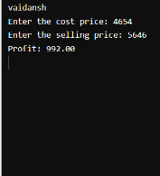

Programme-94

**Write a C program to input marks of five subjects Physics, Chemistry, Biology, Mathematics and Computer. Calculate percentage and grade according to following:**

Percentage >= 90% : Grade A Percentage >= 80% : Grade B Percentage >= 70% : Grade C Percentage >= 60% : Grade D Percentage >= 40% : Grade E Percentage < 40% : Grade F

INPUT

#include <stdio.h>

int main() {

char name[50];

float physics, chemistry, biology, mathematics, computer, total, percentage;

printf("Enter your name: ");

scanf("%s", name);

printf("Enter marks in Physics: ");

scanf("%f", &physics);

printf("Enter marks in Chemistry: ");

scanf("%f", &chemistry);

printf("Enter marks in Biology: ");

scanf("%f", &biology);

printf("Enter marks in Mathematics: ");

scanf("%f", &mathematics);

printf("Enter marks in Computer: ");

scanf("%f", &computer);

total = physics + chemistry + biology + mathematics + computer;

percentage = (total / 500) * 100;

printf("\n%s, your total marks: %.2f\n", name, total);

printf("Your percentage: %.2f%%\n", percentage);

if (percentage >= 90) {

printf("Grade: A\n");

} else if (percentage >= 80) {

printf("Grade: B\n");

} else if (percentage >= 70) {

printf("Grade: C\n");

} else if (percentage >= 60) {

printf("Grade: D\n");

} else if (percentage >= 40) {

printf("Grade: E\n");

} else {

printf("Grade: F\n");

}

return 0;

}

OUTPUT

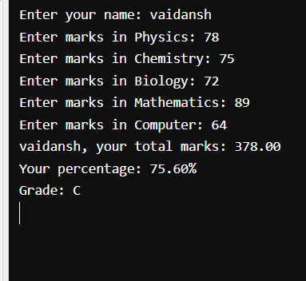

Programme-95

**Write a C program to input basic salary of an employee and calculate its Gross salary according to following: Basic Salary <= 10000 : HRA = 20%, DA = 80% Basic Salary <= 20000 : HRA = 25%, DA = 90% Basic Salary > 20000 : HRA = 30%, DA = 95%**

INPUT

#include <stdio.h>

int main() {

char name[50];

float basicSalary, hra, da, grossSalary;

printf("Enter your name: ");

scanf("%s", name);

printf("Enter your basic salary: ");

scanf("%f", &basicSalary);

if (basicSalary <= 10000) {

hra = 0.20 * basicSalary;

da = 0.80 * basicSalary;

} else if (basicSalary <= 20000) {

hra = 0.25 * basicSalary;

da = 0.90 * basicSalary;

} else {

hra = 0.30 * basicSalary;

da = 0.95 * basicSalary;

}

grossSalary = basicSalary + hra + da;

printf("\n%s, your gross salary is: %.2f\n", name, grossSalary);

return 0;

}

OUTPUT

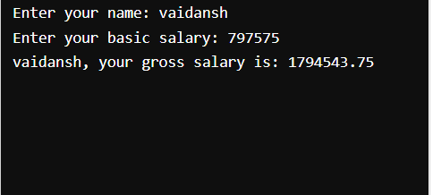

Programme-96

**Write a C program to input electricity unit charges and calculate total electricity bill according to the given condition: For first 50 units Rs. 0.50/unit For next 100 units Rs. 0.75/unit For next 100 units Rs. 1.20/unit For unit above 250 Rs. 1.50/unit An additional surcharge of 20% is added to the bill**

INPUT

#include <stdio.h>

int main() {

char name[50];

int units;

float totalBill;

printf("Enter your name: ");

scanf("%s", name);

printf("Enter the electricity units consumed: ");

scanf("%d", &units);

if (units <= 50) {

totalBill = units * 0.50;

} else if (units <= 150) {

totalBill = 50 * 0.50 + (units - 50) * 0.75;

} else if (units <= 250) {

totalBill = 50 * 0.50 + 100 * 0.75 + (units - 150) * 1.20;

} else {

totalBill = 50 * 0.50 + 100 * 0.75 + 100 * 1.20 + (units - 250) * 1.50;

}

// Adding surcharge of 20% to the total bill

totalBill += totalBill * 0.20;

printf("\n%s, your total electricity bill is: %.2f\n", name, totalBill);

return 0;

}

OUTPUT

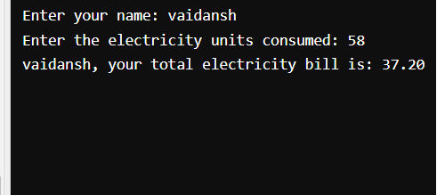

Programme-97

1. **Write a C program to convert specified days into years, weeks and days.**

INPUT

#include <stdio.h>

int main() {

int days, years, weeks;

days = 1329;

// Converts days to years, weeks, and days using if-else statements

if (days >= 365) {

years = days / 365;

days = days % 365;

} else {

years = 0;

}

if (days >= 7) {

weeks = days / 7;

days = days % 7;

} else {

weeks = 0;

}

printf("Years: %d\n", years);

printf("Weeks: %d\n", weeks);

printf("Days: %d\n", days);

return 0;

}

OUTPUT

